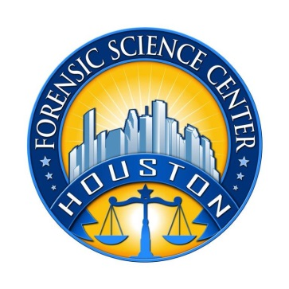

Houston Forensic Science Center, Inc.

QUALITY SPECIALIST
Houston Forensic Science Center (HFSC) is an independent organization created by Houston Mayor Annise Parker and the Houston City Council to provide forensic science services formerly delivered by the Houston Police Department. HFSC has been officially registered as a Texas local government corporation* since June 26, 2012.

Houston Forensic Science Center is seeking for a full-time Quality Specialist.

POSITION SUMMARY
Under the direction of the Quality Director, implements, monitors, and reviews the quality activities within the Houston Forensic Science Center. Partners with management and other staff to ensure tasks, documentation and systems meet quality standards. Responsible for facilitating large, complex projects. Provides advice on quality issues to other forensic scientists in the lab as well as to employees in other roles. Serves as a role model in upholding the established standards. Specific duties may include, but not be limited to the following:
- Maintaining and updating the Quality Manual
- Assisting with corrective and preventive actions and root cause analysis
- Participating with risk assessments.
- Conducting periodic quality system audits
- Preparing the laboratory for assessments and audits
- Maintaining document control for laboratory policies and procedures
- Monitoring continued compliance with in-house policies and procedures as well as accreditation standards
- Administering proficiency tests
- Maintaining the blind quality control program
- Fostering a continuous improvement culture within the laboratory
- Other duties as assigned

MINIMUM EDUCATIONAL REQUIREMENTS
The position requires a minimum of bachelor’s degree in a physical science (biology, chemistry, biochemistry,etc) from an accredited college/university (transcripts required). A Master’s Degree in strongly preferred. Direct working experience in FORENSIC casework with a bachelor’s degree in a related field may be considered. Certification in a forensic science discipline or quality-related field is strongly preferred.

MINIMUM EXPERIENCE REQUIREMENTS
A minimum of three (3) years of direct casework experience in an accredited forensic laboratory with a working knowledge of quality systems, audit concepts and document control are required. A minimum of two years of work experience in quality role in a forensic environment may be considered in lieu of casework. Proven previous work experience with ISO standard 17025 may also be considered. Proven expertise in Qualtrax is a plus.

KNOWLEDGE AND SKILL REQUIREMENTS
- Excellent verbal and written communication skills
- Ability to work well with all levels of employees and outside contacts
- Ability to demonstrate an excellent record as a team facilitator
- Ability to demonstrate strong presentation skills
- Demonstrated skills at effective project management
- Demonstrated ability to think critically, troubleshoot effectively and make timely and sound decisions
- Demonstrated ability to work well with details

CONTACT INFORMATION
Interested applicants meeting the job qualification may apply via our website, www.houstonforensicscience.org

Houston Forensic Science Center, Inc. is an Equal Employment Opportunity Employer

*A “local government corporation” is an independent organization that includes the participation of one or more governmental agencies

