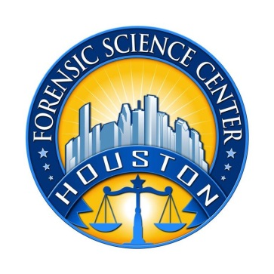

Houston Forensic Science Center, Inc.

QUALITY SPECIALIST
Houston Forensic Science Center (HFSC) is an independent organization created by Houston Mayor Annise Parker and the Houston City Council to provide forensic science services formerly delivered by the Houston Police Department. HFSC has been officially registered as a Texas local government corporation* since June 26, 2012.

Houston Forensic Science Center is seeking for a full-time Quality Specialist.

POSITION SUMMARY
Under the direction of the Corporate Quality Director, implements, monitors, and reviews the quality activities within the Houston Forensic Science Center. Partners with management and other staff to ensure tasks, documentation and systems meet quality standards. Responsible for facilitating large, complex projects. Provides advice on quality issues to other forensic scientists in the lab as well as to employees in other roles. Serves as a role model in upholding the established standards. Specific duties may include, but not be limited to the following:
- Maintaining and updating the Quality Manual
- Maintaining document control for laboratory policies and procedures
- Monitoring continued compliance with in-house policies and procedures as well as accreditation standards
- Monitoring instrument calibration and maintenance
- Assessing the adequacy of technical and administrative reviews
- Administering proficiency tests
- Maintaining training records
- Assisting with corrective and preventive actions and root cause analysis
- Conducting periodic quality system audits
- Preparing the laboratory for assessments and audits
- Expanding the Blind Quality Control Program of HFSC and maintaining documentation

MINIMUM EDUCATIONAL REQUIREMENTS
The position requires a bachelor’s degree in a science-related or quality-based field from an accredited college/university (transcripts required). Quality related certification such as from ASQ is strongly preferred.

MINIMUM EXPERIENCE REQUIREMENTS
A minimum of five (5) years of combined forensic casework as well as quality experience in an accredited forensic laboratory with a working knowledge of quality systems, audit concepts and document control are required. Experience in Forensic Biology/DNA is strongly preferred. Proven expertise in Microsoft Office applications required. Proven expertise in Qualtrax is strongly preferred.
KNOWLEDGE AND SKILL REQUIREMENTS
- Excellent verbal and written communication skills
- Ability to work well with all levels of employees and outside contacts
- Ability to demonstrate an excellent record as a team facilitator
- Ability to demonstrate strong presentation skills
- Demonstrated skills at effective project management
- Demonstrated ability to think critically, troubleshoot effectively and make timely and sound decisions
- Demonstrated ability to work well with details

CONTACT INFORMATION
Interested applicants meeting the job qualification may apply via our website, www.houstonforensicscience.org

Houston Forensic Science Center, Inc. is an Equal Employment Opportunity Employer

*A “local government corporation” is an independent organization that includes the participation of one or more governmental agencies

