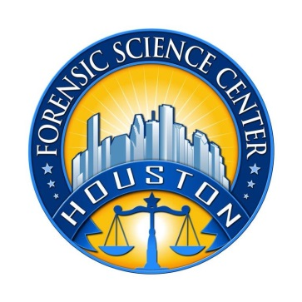
Houston Forensic Science Center, Inc.

Forensic Scientist – Seized Drugs

Houston Forensic Science Center is an independent organization created by Houston Mayor Annise Parker and the Houston City Council to provide forensic science services formerly delivered by the Houston Police Department. Houston Forensic Science Center has been officially registered as a Texas Local Government Corporation* since June 26, 2012.

POSITION SUMMARY
Under the direction of the Manager of Seized Drugs, the Forensic Analyst performs routine to moderately complex analyses of evidence for the presence of suspected controlled substances. Specific duties may include, but are not limited to, performing the following:
- Document all evidence promptly immediately upon receipt.
- Analyze evidence for the presence of controlled substances using established procedures and guidelines, keep precise records, and develop scientific conclusions.
- Generate accurate reports within 48 hours of the completion of analysis.
- Secure, preserve, inventory, and store evidence according to established procedures.
- Maintain security and chain-of-custody documentation of evidence at all times.
- Perform basic maintenance and calibration of instrumentation as well as necessary quality control checks and complete appropriate documentation.
- Provide technical assistance to stakeholders including but not limited to law enforcement agencies and civic groups.
- Provide accurate and effective expert testimony in court regarding the scientific conclusions obtained from the analysis of evidence.
- Participate in laboratory projects and complete tasks assigned by the supervisor.

MINIMUM EDUCATIONAL REQUIREMENTS
Requires a bachelor’s degree in chemistry, or forensic chemistry. A Master’s degree is strongly preferred. College coursework should include a minimum of 30 hours of chemistry and meet the education requirement for the Texas Forensic Science Commission for a Seized Drug Analyst which includes a minimum of 16 hours of chemistry above general coursework as well as 3 hours of statistics.

MINIMUM EXPERIENCE REQUIREMENTS
No experience is required at entry level; however, work or internship experience in a forensic environment is strongly preferred.

KNOWLEDGE AND SKILL REQUIREMENTS
- Working knowledge and experience with a Laboratory Information Management System (LIMS) is preferred.
- Proficiency in Microsoft Office applications, specifically Word, Excel, PowerPoint, and Outlook.
- Demonstrated ability to work with frequent interruptions and changing priorities.
- Demonstrated ability to establish and maintain effective communications and working relationships with fellow staff members, internal clients, and external clients.
- Working knowledge of principles, practices, and terminology of analytical chemistry.
CONTACT INFORMATION
Interested applicants meeting the job qualification can visit our website, www.houstonforensicscience.org to apply.

Houston Forensic Science Center is an Equal Employment Opportunity Employer

*A “local government corporation” is created to aid and act on behalf of one or more local governments to accomplish any governmental purpose of those governments.

