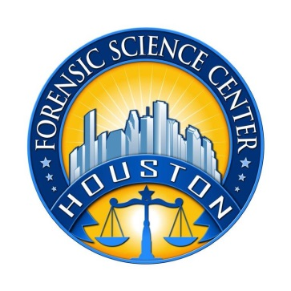
Houston Forensic Science Center, Inc.
1301 Fannin St. Suite 170
Houston, TX 77002

Forensic Analyst – Digital

Houston Forensic Science Center, Inc. (HFSC), is an independent organization created by Houston Mayor Annise Parker and the Houston City Council to provide forensic science services formerly delivered by the Houston Police Department. HFSC has been officially registered as a Texas Local Government Corporation* since June 26, 2012.

HFSC is now seeking a full-time Forensic Analyst in the Forensic Multimedia/Digital Unit. HFSC offers a competitive salary and benefit package that is commensurate with experience.

POSITION SUMMARY
The successful candidate will be responsible for forensic examinations of computer and cell phone evidence. The basic responsibilities of the analyst include but are not limited to:
- Preserve and analyze data from electronic data sources, including computers, servers, and mobile devices, ensuring that the evidential integrity of the data is not compromised.
- Report detailed findings in preparation for review by investigators, prosecutors, or legal counsel, explaining complex technical concepts to nontechnical people.
- Research and develop new computer forensic tools and methodologies.
- Assess and troubleshoot a variety of technical issues.
- Form and articulate expert opinions based on analysis and report findings.
- Provide expert testimony in depositions, trials, and other proceedings.
- Must be willing to be on-call to respond to calls after hours/weekends/holidays.

MINIMUM EDUCATIONAL REQUIREMENTS
Bachelor’s degree in Digital Media Forensics, Computer Science, Forensic Science, or closely related field is required. A graduate degree is strongly preferred. Equivalent experience as a multimedia or digital forensic analyst may be considered in lieu of a degree.
MINIMUM EXPERIENCE REQUIREMENTS
A minimum of two years’ experience working with analysis of digital evidence is required. Demonstration expertise with clarification tools is also required. Demonstrated proficiency in the examination and enhancement of digital evidence. An advanced degree may be considered as meeting partial experience requirements. CFCE or GFCE certification is also required. CCO, CCPA, GSAF, EnCE, or CCME or the ability to quickly gain certification is strongly preferred.
KNOWLEDGE AND SKILL REQUIREMENTS
- Knowledge of ISO/IEC 17025 accreditation standards.
- Demonstrated skill in oral and written communication.
- Demonstrated skills in handling multiple tasks and prioritizing work assignments.
- Demonstrated ability to effectively handle conflict and uncertain situations.
- Demonstrated ability to work with frequent interruptions and changing priorities.
- Demonstrated ability to establish and maintain effective communications and working relationships with fellow employees, internal customers, and external customers.
- Ability to lift computers that can weigh up to 50 lbs.

CONTACT INFORMATION
Interested applicants meeting the job qualifications may apply via our website, www.houstonforensicscience.org

Houston Forensic Science Center, Inc., is an Equal Employment Opportunity Employer

*A “local government corporation” is created to aid and act on behalf of one or more local governments to accomplish any governmental purpose of those governments.

