Houston Forensic Science Center, Inc.
1301 Fannin St. Suite 170
Houston, TX 77002

Experienced Crime Scene Investigator
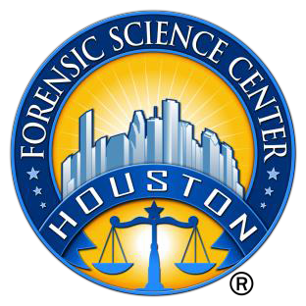

Houston Forensic Science Center, Inc. (HFSC), is an independent organization created by Houston Mayor Annise Parker and the Houston City Council to provide forensic science services formerly delivered by the Houston Police Department. HFSC has been officially registered as a Texas Local Government Corporation* since June 26, 2012.

POSITION SUMMARY

The Crime Scene Investigator is responsible for identifying, documenting, collecting, and interpreting evidence from complex and high-profile crime scenes, typically in conjunction with an ongoing police investigation. This position responds to assignments twenty-four hours a day, seven days a week. Principal responsibilities of the position include, but are not limited to, the following:
- Process complex crime scenes, including the identification, documentation, collection, preservation, and submission of evidence.
- Generate detailed offense reports.
- Photograph and videotape major crime scenes.
- Produce detailed crime scene diagrams.
- Respond to call-ups during off-duty hours.
- Complete specialized classroom and on-the-job training as required.
- Perform other duties as assigned.

MINIMUM EDUCATIONAL REQUIREMENTS
A bachelor’s degree in a related physical science, criminal justice, or forensic science is required; experience may be considered in lieu of the degree. Active IAI Certification as a crime scene investigator or analyst is strongly preferred; the successful applicant must be able to achieve certification within one year of hire. Certification must be maintained throughout employment with Houston Forensic Science Center.

MINIMUM EXPERIENCE REQUIREMENTS
A minimum of two years of experience in the role of crime scene investigator is REQUIRED.

KNOWLEDGE AND SKILL REQUIREMENTS
- Excellent interpersonal skills, with the demonstrated ability to interact effectively with citizens or family members who are experiencing traumatic events such as a horrific crime.
- Ability to work unsupervised or in a small group after the completion of appropriate training, completing complex tasks and procedures with minimal or no guidance.
- Exceptional written and verbal communication skills
- Possession or ability to obtain a Texas driver’s license to operate a vehicle loaded with Crime Scene Unit equipment and tools
- Proven expertise in Microsoft Office applications, specifically Word, Excel, PowerPoint, and Outlook, and Microsoft’s cloud-based service, SharePoint, is required. Working knowledge of a Laboratory Information Management System (LIMS) and Microsoft Access is a plus.
- Ability to meet the physical requirements with or without accommodations
    - Ability to stand and walk around for extended periods of time
- Willingness to work extended hours with little or no advance notice.
- Ability to complete tasks regardless of the weather or temperature
- Ability to complete tasks regardless of foul odors or insect activity
- Ability to lift and carry, push or pull up to 150 lbs
CONTACT INFORMATION
- Interested applicants fitting the job qualification may apply via our website, www.houstonforensicscience.org

Houston Forensic Science Center, Inc., is an Equal Employment Opportunity Employer

*A “local government corporation” is created to aid and act on behalf of one or more local governments to accomplish any governmental purpose of those governments.

