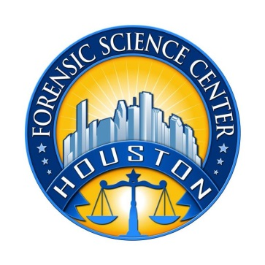
Houston Forensic Science Center, Inc.
1301 Fannin St. Suite 170
Houston, TX 77002

Forensic Analyst – Multimedia
AUDIO/VIDEO

Houston Forensic Science Center, Inc. (HFSC), is an independent organization created by Houston Mayor Annise Parker and the Houston City Council to provide forensic science services formerly delivered by the Houston Police Department. HFSC has been officially registered as a Texas Local Government Corporation* since June 26, 2012.

HFSC is now seeking a full-time Forensic Analyst in the Forensic Multimedia (Audio/Video) Unit. HFSC offers a competitive salary and benefit package that is commensurate with experience.

POSITION SUMMARY
The successful candidate will be responsible for forensic examination of audio and video evidence. The basic responsibilities of the analyst include but are not limited to:
- Analysis of audio and video evidence, whether analog or digital in nature, used in criminal investigations.
- Specialized technical work in the clarification/enhancement, conversion, repair, and reconstruction of audio and video evidence.
- Retrieval of evidence from analog and digital CCTV systems, both in the lab and at crime scenes.
- Conducting validation testing and performance verification of hardware/software tools.
- Troubleshoot and identify adjustment, repair, and/or replacement needs for malfunctioning or non-working audio/video systems and equipment.
- Assisting with developing and conducting training on audio/video analysis techniques as needed.
- Producing reports and testifying to the findings of analysis.
- Must be willing to be on-call to respond to calls after hours/weekends/holidays.

MINIMUM EDUCATIONAL REQUIREMENTS
Bachelor’s degree in Digital Media Forensics, or closely related field is required. A graduate degree in Media Forensics is strongly preferred. Equivalent experience as a multimedia forensic analyst may be considered in lieu of a degree. .

MINIMUM EXPERIENCE REQUIREMENTS
A minimum of two years’ experience working with audio/video analysis and/or clarification tools, with demonstrated proficiency in the examination and enhancement of audio/video evidence. LEVA or IAI certification or the ability to quickly gain certification is strongly preferred. An advanced degree may be considered as meeting partial experience requirements.

KNOWLEDGE AND SKILL REQUIREMENTS
- Knowledge of ISO/IEC 17025 accreditation standards.
- Demonstrated skill in oral and written communication.
- Additional specialized course(s) in basic forensic video analysis (LEVA, Resolution Video, etc.) is preferred.
- Demonstrated skills in handling multiple tasks and prioritizing work assignments.
- Demonstrated ability to effectively handle conflict and uncertain situations.
- Demonstrated ability to work with frequent interruptions and changing priorities.
- Demonstrated ability to establish and maintain effective communications and working relationships with fellow employees, internal customers, and external customers.
- Ability to lift computers that can weigh up to 50 lbs.

CONTACT INFORMATION
Interested applicants meeting the job qualifications may apply via our website, www.houstonforensicscience.org

Houston Forensic Science Center, Inc., is an Equal Employment Opportunity Employer

*A “local government corporation” is created to aid and act on behalf of one or more local governments to accomplish any governmental purpose of those governments.

