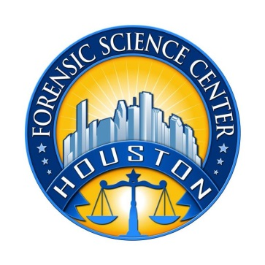

Houston Forensic Science Center, Inc.
500 Jefferson St. 13th floor
Houston, TX 77002

NIBIN TECHNICIAN

Houston Forensic Science Center, Inc. (HFSC), is an independent organization created by Houston Mayor Annise Parker and the Houston City Council to provide forensic science services formerly delivered by the Houston Police Department. HFSC has been officially registered as a Texas Local Government Corporation* since June 26, 2012.

HFSC is now seeking a full-time NIBIN Technician. HFSC offers a competitive salary and benefit package that is commensurate with experience.

POSITION SUMMARY

The primary job duties of the NIBIN Technician are to process firearms and firearms related evidence as part of the organization’s ballistic imaging program. Specific duties of the NIBIN Technician may include, but not be limited to, performing the following duties with little or no direct supervision:
- Examination and test firing of firearms
- Microscopic screening of fired cartridge cases for NIBIN entry
- Entry into the organization’s NIBIN database
- Reviewing entry results in the organization’s NIBIN database
- Issuing and reviewing notifications pertaining to work performed
- Maintain chain of custody and proper examination documentation within the Laboratory Management Information System.

MINIMUM EDUCATIONAL REQUIREMENTS
- The position requires a Bachelor’s degree in forensic science, a physical/natural science, criminal justice, or closely related field from an accredited university. Equivalent relevant experience in an accredited forensic laboratory environment, preferably in Firearms examination or NIBIN, may be considered in lieu of a degree. The successful candidate must be able to gain Forensic Technician licensure from the Texas Forensic Science Commission within the first quarter of employment.

MINIMUM EXPERIENCE REQUIREMENTS
Minimum of one year of experience in evidence handling or work in a forensic lab environment is strongly preferred.

KNOWLEDGE AND SKILL REQUIREMENTS
- Demonstrated skill in oral and written communication
- Demonstrated skill in using computers and related software applications
- Demonstrated skills in handling multiple tasks and prioritizing work assignments
- Demonstrated ability to effectively handle conflict and uncertain situations
- Demonstrated ability to work with frequent interruptions and changing priorities
- Demonstrated ability to establish and maintain effective communications and working relationships with fellow employees, internal customers, and external customers.

CONTACT INFORMATION
Interested applicants meeting the job qualifications may apply via our website, www.houstonforensicscience.org

Houston Forensic Science Center, Inc., is an Equal Employment Opportunity Employer

*A “local government corporation” is created to aid and act on behalf of one or more local governments to accomplish any governmental purpose of those governments.

