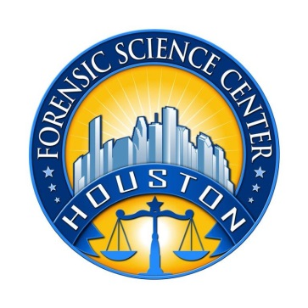

Houston Forensic Science Center, Inc.

FIREARMS EXAMINER TRAINEE
Houston Forensic Science Center, Inc. (HFSC), is an independent organization created by Houston Mayor Annise Parker and the Houston City Council to provide forensic science services formerly delivered by the Houston Police Department. HFSC has been officially registered as a Texas Local Government Corporation* since June 26, 2012.

Houston Forensic Science Center is seeking a full-time Firearms Examiner.

POSITION SUMMARY
The primary job duties of the Firearms Examiner are to examine and interpret firearms evidence associated with alleged criminal acts. Specific duties of the Firearms Examiner may include, but not be limited to performing the following duties with little or no direct supervision:
- Examination and test firing of firearms
- Comparisons of fired bullets and cartridge cases
- Entering specimens into NIBIN and reviewing correlations
- Acting as a second/reviewing examiner on cases completed by other examiners
- Conducting administrative and technical reviews of case records
- Restoration of obliterated serial numbers on firearms
- Testifying in courts of law regarding analyses performed

MINIMUM EDUCATIONAL REQUIREMENTS
- The position requires a minimum of a bachelor’s degree in forensic science or a chemical, physical, or biological science from an accredited college or university (transcripts required). College coursework should meet the requirements for the Texas Forensic Science Commission Forensic Analyst license. As a result, completion of college-level Statistics or the ability to complete a Statistics course within the 6 months of hire is also required.
- The successful candidate must be able to gain Forensic Analyst licensure from TFSC within the first six months of employment.
- Certification in Firearms Examination through AFTE strongly preferred.
- Active licensure or direct work experience as a Firearms Examiner may be considered in lieu of the education requirement.

MINIMUM EXPERIENCE REQUIREMENTS
Experience in a Forensic lab environment, specifically in evidence handling is strongly preferred.

KNOWLEDGE AND SKILL REQUIREMENTS
- Knowledge of firearms examination practice and procedure
- Knowledge of ISO-17025 accreditation standards
- Demonstrated skill in oral and written communication
- Demonstrated skill in using computers and related software applications
- Demonstrated skills in handling multiple tasks and prioritizing work assignments
- Demonstrated ability to effectively handle conflict and uncertain situations
- Demonstrated ability to work with frequent interruptions and changing priorities
- Demonstrated ability to establish and maintain effective communications and working relationships with fellow employees, internal customers, and external customers.

CONTACT INFORMATION
Interested applicants meeting the job qualification may apply via our website, www.houstonforensicscience.org. To be considered, please attach all of the following as your application:
- Resume or CV
- A cover letter of at least 500 words indicating your motivation in becoming a Firearms Examiner.

Houston Forensic Science Center, Inc. is an Equal Employment Opportunity Employer
*A “local government corporation” is created to aid and act on behalf of one or more local governments to accomplish any governmental purpose of those governments..

