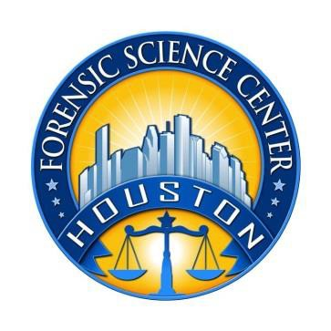
Houston Forensic Science Center, Inc.
EXPERIENCED LATENT PRINT
EXAMINER

Houston Forensic Science Center is an independent organization to provide forensic science services formerly delivered by the Houston Police Department. Houston Forensic Science Center, Inc. has been officially registered as a Texas Local Government Corporation* since June 26, 2012.

Houston Forensic Science Center is seeking a full-time Experienced Latent Print Examiner.

POSITION SUMMARY
The Latent Print Examiner will document, evaluate, analyze, and preserve custody of friction ridge evidence,
utilizing various comparison techniques. He/she will conduct computer database searches, updating and modifying information in databases as appropriate. The successful applicant will utilize methods and equipment for the enhancement of latent print evidence. He/she will compose and/or complete supplemental reports and provide documentation of analysis to investigative units on the status of latent print evidence, and transport evidence and/or property to storage location and/or criminal court. The Latent Print Examiner will also assist other law information agencies in comparative analysis and may testify as an expert witness.

MINIMUM EDUCATIONAL REQUIREMENTS
The position requires a bachelor’s degree in a Physical or Forensic Science from an accredited college or university with major coursework in a field related to the job. Certification as a Latent Print Examiner with the International Association for Identification (IAI) is strongly preferred.

MINIMUM EXPERIENCE REQUIREMENTS
A minimum of three years’ experience in a forensic laboratory as a latent print examiner required. Direct Working Experience as a Latent Print Examiner may be considered in lieu of educational requirements.

KNOWLEDGE AND SKILL REQUIREMENTS
- Knowledge of latent print practice and procedure
- Knowledge of crime scene policy and procedure
- Demonstrated skill in oral and written communication
- Demonstrated skill in using computers and related software applications
- Demonstrated skill in handling multiple tasks and prioritizing work assignments
- Demonstrated ability to effectively handle conflict and uncertain situations
- Demonstrated ability to work with frequent interruptions and changing priorities
- Demonstrated ability to establish and maintain effective communications and working relationships with internal and external customers

CONTACT INFORMATION
Interested applicants meeting the job qualifications may apply via our website, www.houstonforensicscience.org.

Houston Forensic Science, Inc. is an Equal Employment Opportunity Employer

*A “local government corporation” is an independent organization that includes the participation of one or more governmental agencies.

