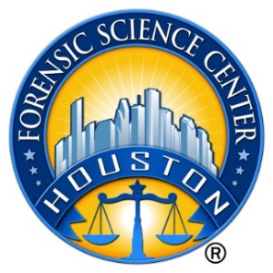

Houston Forensic Science Center, Inc.

Postdoctoral Research Associate

Houston Forensic Science Center (HFSC) is an independent organization created by Houston Mayor Annise Parker and the Houston City Council to provide forensic science services formerly delivered by the Houston Police Department. HFSC has been officially registered as a Texas local government corporation* since June 26, 2012.

HFSC is now seeking a full-time Postdoctoral Research Associate. This position is grant-funded for a 12 month timeframe only.

POSITION SUMMARY
Reporting to the Director of the Research and Development section, this postdoctoral associate works both independently and in conjunction with other team members to evaluate and characterize the effects of adulterants on drugs that have been seized and submitted as evidence via the use of mass spectrometry. Specific responsibilities include, but are not limited to, the following:

- Responsible for utilizing (Gas Chromatography-Mass Spectrometry) GC-MS to analyze controlled substance
- Responsible for the collection, analysis and interpretation of research data
- Responsible for maintaining detailed documentation of experimental work
- Responsible for authoring technical reports of research findings and publish research

MINIMUM EDUCATION REQUIREMENTS
A Ph.D. in chemistry, preferably in Analytical Chemistry or a closely related physical/natural science is required.
MINIMUM EXPERIENCE REQUIREMENTS
3-5 years of experience using GC-MS is required; Education may be considered in lieu of experience. Previous experience in a forensic lab environment is strongly preferred. Previous research experience is a plus. Proven experience in analysis of statistical data is preferred.

KNOWLEDGE AND SKILL REQUIREMENTS
- Proven analytical instrumentation skills including operation, maintenance, and troubleshooting are required.
- Proficiency with Microsoft Office applications (Outlook, Word, Excel and PowerPoint, SharePoint).
- Working knowledge of Laboratory Information Management Systems (LIMS) and Access database is a plus.
- Demonstrated interest in the field of research
- Demonstrated ability to work as part of a multidisciplinary team
- Demonstrated ability to work in a challenging and dynamic work environment
- Demonstrated skills in handling multiple tasks and prioritizing work assignments
- Demonstrated ability to work with frequent interruptions and changing priorities
- Excellent interpersonal, verbal, and written communication skills
\
CONTACT INFORMATION
Interested applicants meeting the job qualifications may apply via our website, www.houstonforensicscience.org

Houston Forensic Science Center, Inc., is an Equal Employment Opportunity Employer
*A “local government corporation” is created to aid and act on behalf of one or more local governments to accomplish any governmental purpose of those governments.

