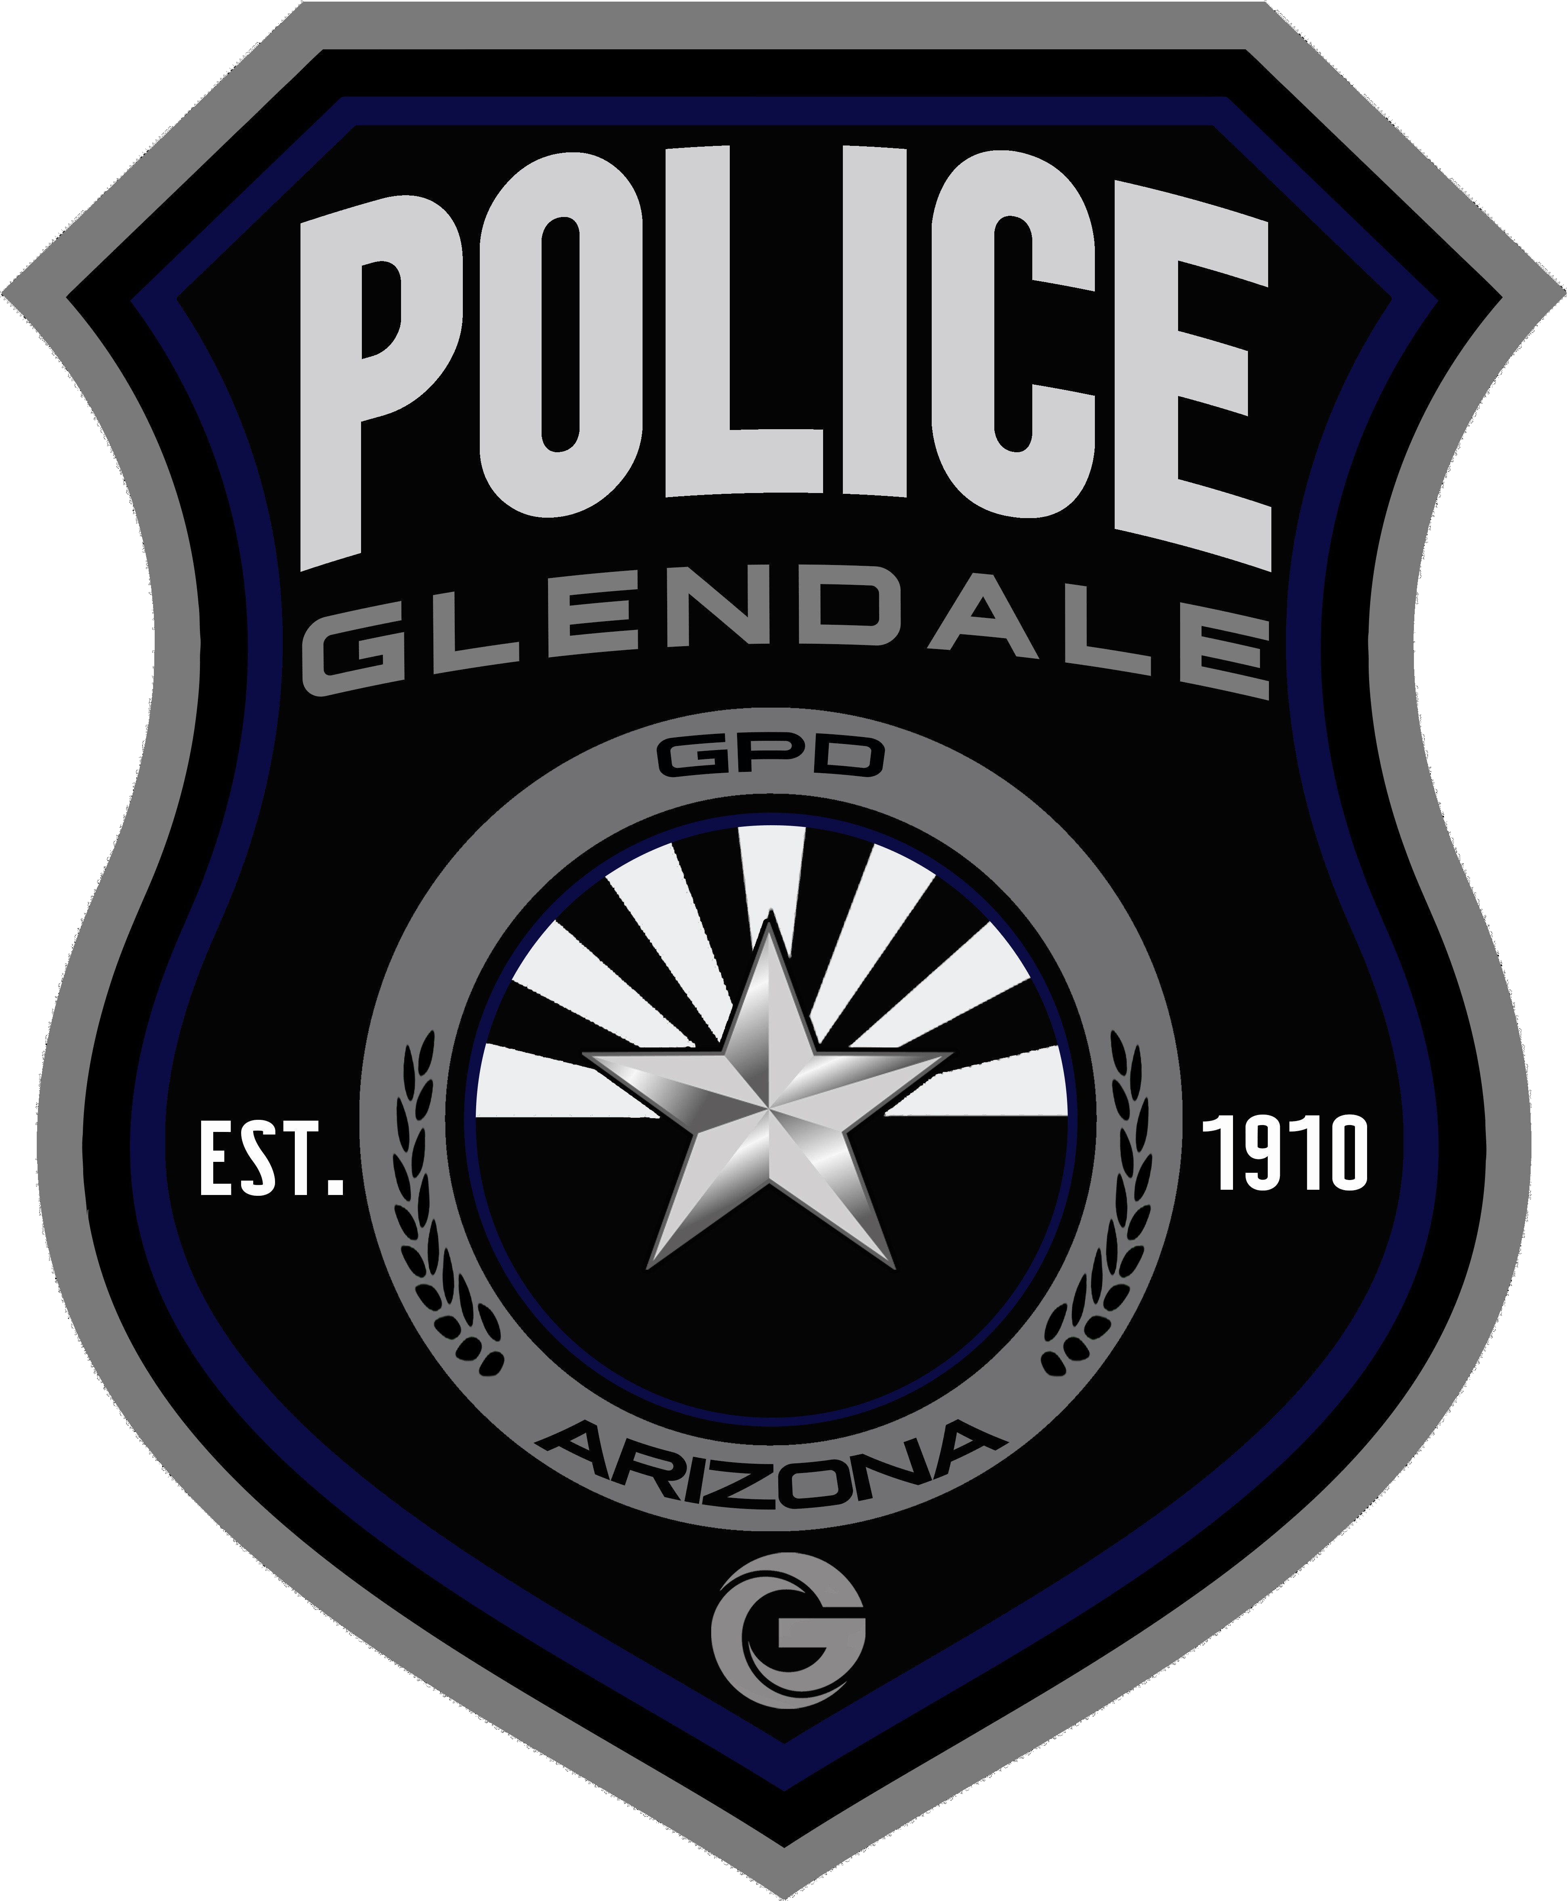

GPD FSU QIN:
Glendale Police Department Forensic Services Unit Quality Issue Notification

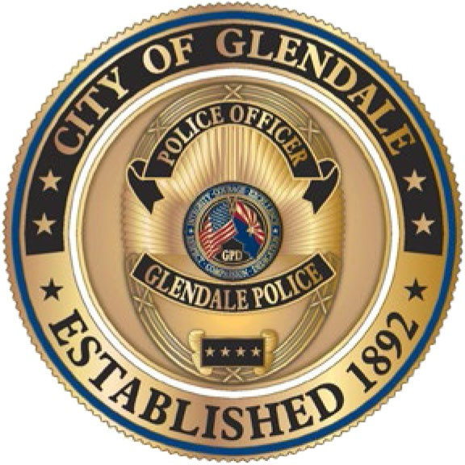
Date of Occurrence: Date Reported: Reported By: Identification of Nonconformance (description of issue):

Case Number(s):
Significance of Nonconformance:

Evaluation and Classification of Nonconformance:
Risk Analysis Rating:
Classification of Issue: □ Nonconformance with CAP
□ Nonconformance without CAP
Type of Error:
□ Administrative
□ Analytical/Interpretive □ Deviation □ Systematic
□ Test Method □ N/A

Applicable Policy(ies):
Authorized: Lab Director
FSU_ QA_001 Version 1.1 Revised 3/10/2023

Work Halted: □No
Comments:
□Yes
Approved by:
Date Performed:
Customer Notification Needed?: □No □Yes
Comments:
Date Performed:
Disclosed to ANAB?:
Comments:
□No
□Yes
Date Performed:

Discussion Notes/Root Cause Analysis:

Action Plan/Corrective Action Plan (CAP):

Authorized: Lab Director
FSU_ QA_001 Version 1.1 Revised 3/10/2023

Approval of Root Cause Analysis and Corrective Action Plan:
Approved by:
Date:
Additional Acknowledgement or Approval:
Review completed by Quality on:
Work Resumed: □ Yes □ N/A Date:
Monitoring/Follow Up:

Performed By:

Authorized: Crime Laboratory Director
Completion of Nonconformance:
Completion Date:
Approved by:
Date:
Approved by:
Date:
Approved by:
Date:
FSU_ QA_001 Version 1.1 Revised 3/10/2023

