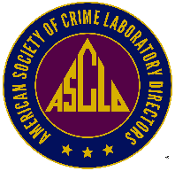
  - American Society of Crime Laboratory Directors, Inc.®

Application for Regular Membership

Sponsor Form

Note to Sponsors
A more extensive endorsement of the applicant may be made by appending a letter of recommendation to this page. The form letter below, however, is sufficient for the purpose of the ASCLD, Inc. bylaws. Please sign it, in addition to any further endorsement you may wish to make.

How long have you known the applicant?
To your knowledge, is/has the applicant:
Currently engaged in forensics? | ☐ YES ☐ NO
Of good character? | ☐ YES ☐ NO
Ever censured for unethical conduct? | ☐ YES ☐ NO

To whom it may concern:

____________________________ , who has applied for Regular Membership in the American Society of Crime Laboratory Directors, Inc., is known to me, and I have certain knowledge that (s)he is currently employed as a Forensic Science practitioner. I endorse the application without reservation, and believe that, if accepted into membership, (s)he will be a credit to the corporation.

Sponsor’s Printed Name
Sponsor’s Signature
Date Signed

**Please send completed sponsor form to: Office@ASCLD.ORG

