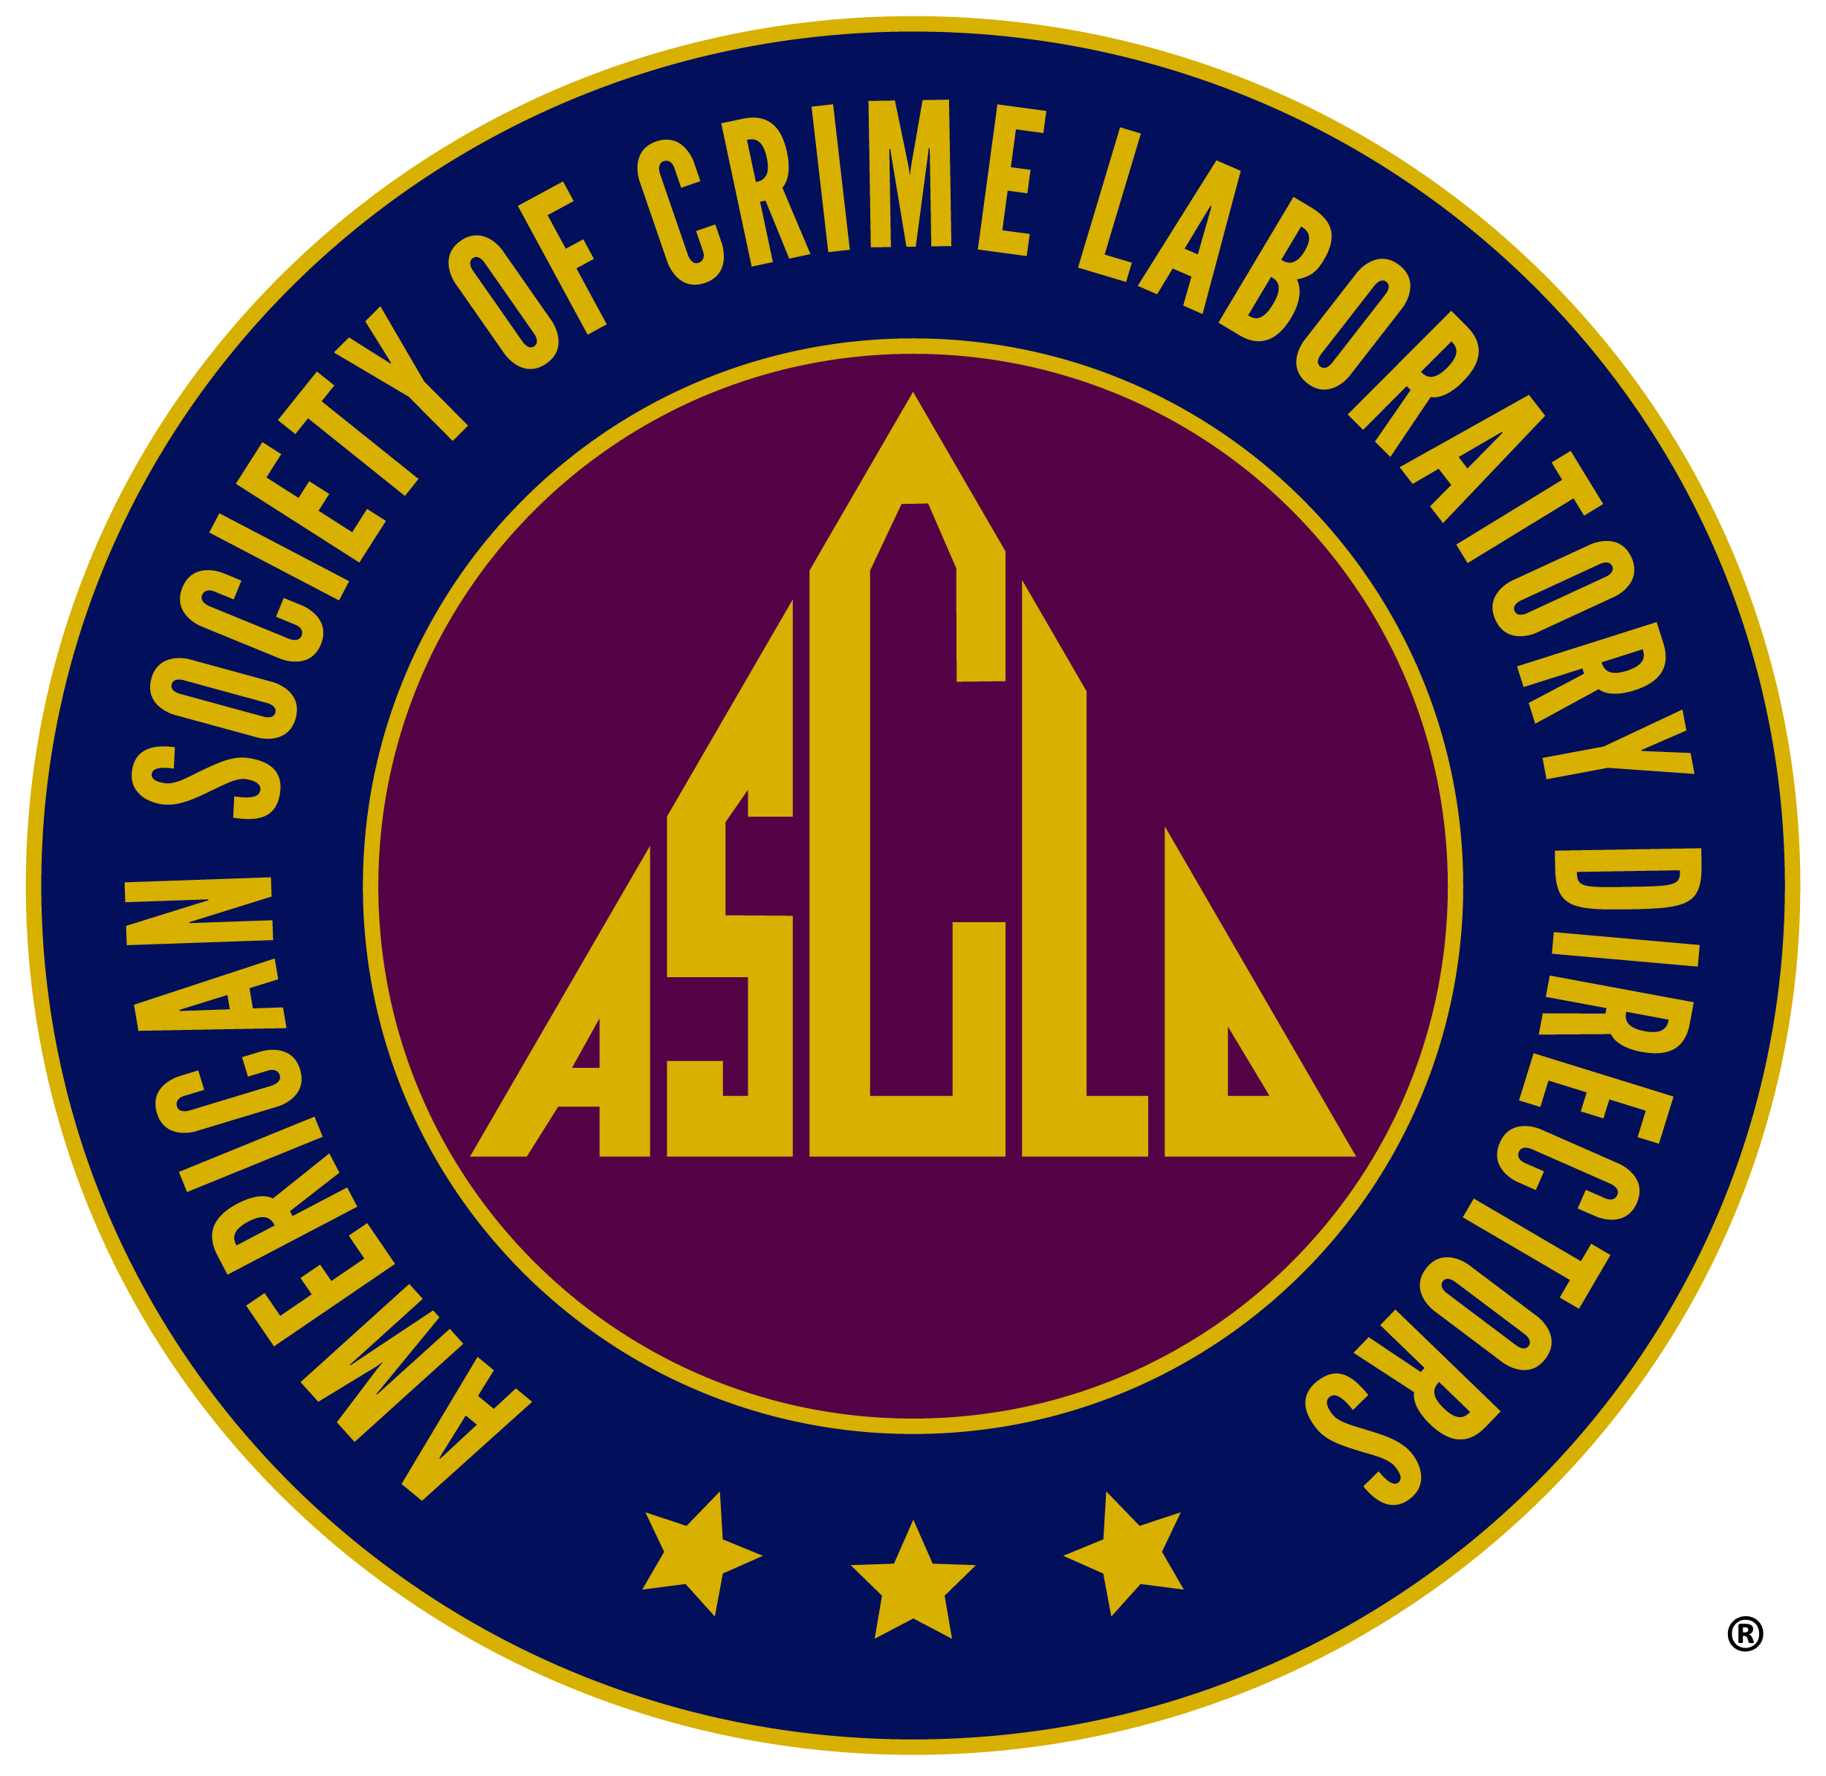

- COMPLETE THE FOLLOWING
Print Form

Name | Your Former Laboratory Affiliation/Title:
Current Mailing Address: | Your Current Title/Position (If applicable):
Telephone | Fax Number:
E‐Mail Address: | List any committee preference(s):
LABORATORY MANAGEMENT EXPERIENCE

Employer | Dates | Position
- PAYMENT INSTRUCTIONS
The application fee for Retired Membership is $75.00. This amount will also cover membership dues for the current year if candidate is voted into membership.
Paid via: U.S. Check or Money Order Bank/Credit Card
- Payments are in U.S. Dollars. When paying application fee, send a U.S. Money order, a check drawn on a U.S. bank or a check drawn on a non‐U.S. Bank that has a U.S. Bank Affiliate listed directly on the check (e.g. – Citicorp, Chemical Bank or Chase Manhattan).
- Checks are payable to “ASCLD, Inc.”
- Do not send non‐U.S. Money Orders or non‐U.S. postal money orders.
- To pay by bankcard, provide the information below as instructed.

CREDIT CARD

ASCLD – Bank Card Application Fee Payment Visa MC Discover American Express
Applicant Name: Account Number:
CVV (3 or 4 digit code on back of card):
Cardholder Name: Cardholder Signature:
Billing address (for the card used):

Expiration date:

Membership Application Fee: $75.00

- SIGN APPLICATION BELOW; RETURN WITH $75.00 APPLICATION FEE (or provide credit card information above) TO:
ASCLD, Inc.
65 Glen Road
Suite 123
Garner, NC 27529
I hereby certify that I have been a regular member in good standing and am no longer eligible for Regular Membership. I agree to work for the objectives, support the bylaws and abide by the code of ethics of the American Society of Crime Laboratory Directors, Inc.

Applicant’s Signature: Date:

Questions: office@ascld.org

