ASCLD FRC LEAP Collaboration Award 2021
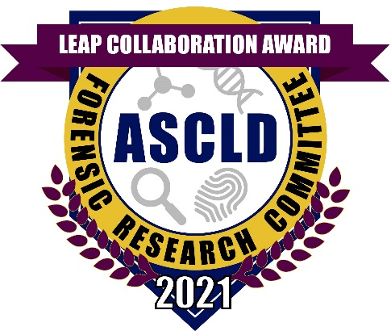

The Forensic Research Committee of the American Society of Crime Laboratory Directors announces the LEAP Collaboration Award. The goal of the award is to recognize an outstanding partnership between LEAP participating academic and operational forensic laboratories.

Award: the winners will be recognized at the 2021 ASCLD Annual Symposium and will receive a plaque. The awardees will receive an individualized electronic award icon that can be use on letterhead, reports, e-mail signatures, etc.

Eligibility: open to scientists from all disciplines such as Bio/DNA, drug chemistry, toxicology, fingerprints, questioned documents, trace/microscopy, firearms/toolmarks, and digital/multimedia sciences in LEAP participating operational and academic forensic laboratories.

Criteria:
1) the research is a collaborative effort between an operational and an academic lab that produces novel data, methods, analytical/research tools that contribute to a forensic science discipline such as Bio/DNA, drug chemistry, toxicology, fingerprints, questioned documents, trace/microscopy, firearms/toolmarks, digital/multimedia sciences
2) the partnership is a joint endeavor in which both teams made significant contributions
3) the partnership results in a body of work that is a significant contribution to forensic science
Note: works that have been published in the peer-reviewed literature will receive favorable review

Application Window: December 14th, 2020 - January 18th, 2021

Application Process:
- Complete the application, found at https://www.ascld.org/nominations/
- Include a 1 – 2 page description of the research, specifically addressing the criteria
- Submit the completed application electronically to ascldfrc@gmail.com
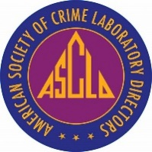
For additional information:
https://www.ascld.org/forensic-research-committee/

