ASCLD FRC Innovation Award 2021
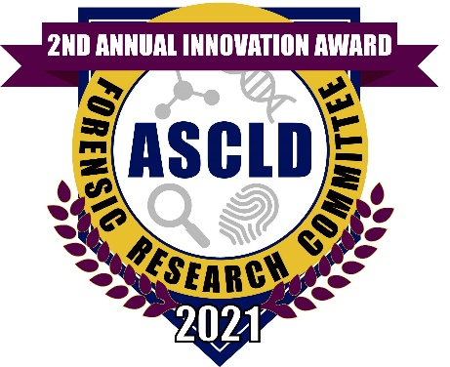

The Forensic Research Committee of the American Society of Crime Laboratory Directors announces the Second Annual Innovation Award. The goal of the award is to recognize activities highlighting new technologies, protocols, or tools that impact the operational forensic science laboratory.

Award: the winner will be recognized at the ASCLD Annual Symposium and will receive a plaque. The awardee will receive an individualized electronic award icon that can be use on letterhead, reports, e-mail signatures, etc.

Eligibility: open to scientists from all disciplines such as Bio/DNA, drug chemistry, toxicology, fingerprints, questioned documents, trace/microscopy, firearms/toolmarks, and digital/multimedia sciences in operational forensic laboratories. The activity should have been completed within past 2 years.

Criteria:
1) innovative methods, tools, and technological approaches that contribute to a forensic science discipline (Bio/DNA, drug chemistry, toxicology, fingerprints, questioned documents, trace/microscopy, firearms/toolmarks, other)
2) the activity has the potential to improve the practice of forensic science
3) the activity has touch points to the ASCLD/FRC needs list (https://www.ascld.org/wp-content/uploads/2019/11/ASCLD-Research-Priority-Areas-2019-2021.pdf )
Note: works that have been published in the peer-reviewed literature will receive favorable review

Application Window: December 14th, 2020 - January 18th, 2021

Application Process:
- Complete the application, found at https://www.ascld.org/nominations/
- Include a 1 – 2 page description of the research, specifically addressing the criteria
- Submit the completed application electronically to ascldfrc@gmail.com
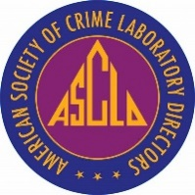
For additional information:
https://www.ascld.org/forensic-research-committee/

