ASCLD FRC
Outstanding Evaluation/Validation Award 2021
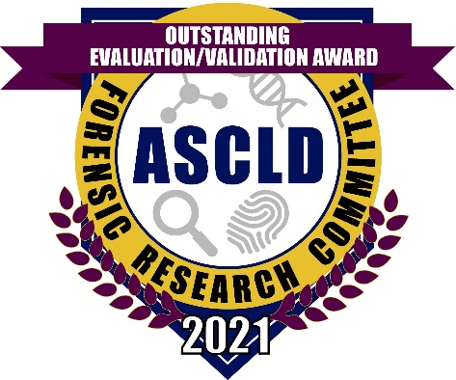

The Forensic Research Committee of the American Society of Crime Laboratory Directors announces the Outstanding Evaluation/Validation Award. The goal of the award is to recognize an outstanding evaluation/validation study that has been submitted to the FRC repository (https://www.ascld.org/validation-evaluation-repository/).

Award: the winner will be recognized at the 2021 ASCLD Annual Symposium and will receive a plaque. The awardee will receive an individualized electronic award icon that can be use on letterhead, reports, e-mail signatures, etc.

Eligibility: open to scientists from all disciplines (bio/DNA, drug chemistry, toxicology, fingerprints, questioned documents, trace/microscopy, firearms/toolmarks, other) in operational forensic labs or research laboratories.

Criteria:
1) validation/evaluation of a protocol, method, tool, kit, or assay for use in a forensic science discipline such as Bio/DNA, drug chemistry, toxicology, fingerprints, questioned documents, trace/microscopy, firearms/toolmarks, and digital/multimedia sciences
2) the validation/evaluation is relevant and immediately useful in forensic science casework

Note: studies that have been performed in accordance with SWG or other guidelines, if appropriate, and/or have been published in the peer-reviewed literature will receive favorable review.

Application Window: December 14th, 2020 - January 18th, 2021

Application Process:
- Complete the application, found at https://www.ascld.org/nominations/
- Include a 1 – 2 page description of the study, specifically addressing the criteria
- Submit the completed application electronically to ascldfrc@gmail.com
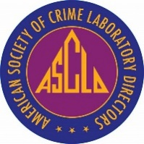
For additional information:
https://www.ascld.org/forensic-research-committee/

