2015 ASCLD Board of Directors Candidate Questionnaire

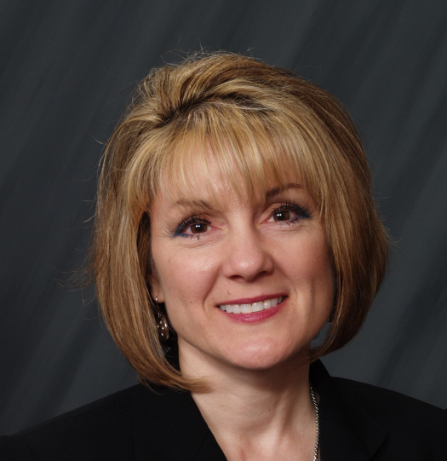

Candidate Name: Deborah A. Leben

Organization: United States Secret Service

Address: 245 Murray Drive, SE Building T5
Washington, DC 20223

Phone Number: 202-406-5269

E-mail: Deborah.Leben@usss.dhs.gov

Education:

M.S.T.M Master of Science in Technology Management, George Mason
University, Fairfax, VA 22030
M.F.S. Master of Forensic Science, The George Washington
University, Washington, DC 22052
B.A. Bachelor of Arts, John Carroll University, University Heights, OH;
University of Akron, Akron, OH 44118

Employment Experience:

Laboratory Director January 2008– present
United States Secret Service, Forensic Services Division
950 H Street, NW, Washington, DC 20223

Operational Oversight: Serve a staff of 45 laboratory professional, technical, and administrative personnel; 7 forensic contractors; and student interns, support over 160 field offices. Oversee a variety of specialized scientific examinations, forensic technologies, and evidence-related matters. Manage administrative and human capital initiatives. Partner with stakeholders in policy development, and long-term, strategic planning efforts regarding research programs, operations, technology modernization, human resources, and funding.

Program Management: Oversee 5 programs in coordination with 6 organizational directorates and 18 divisions/branches. Programs include biometrics, laboratory accreditation, information technology solutions, environmental safety, strategic planning, workforce diversity, laboratory safety and security programs, and scientific services. Develop and manage business continuity and disaster recovery plans for information systems.

Branch Chief – Forensic Automation October 2007 – January 2008
United States Secret Service, Forensic Services Division
950 H Street, NW, Washington, DC 20223

Modernize 2 major enterprise technology programs, manage and execute a multi-million dollar operational budget. Technically and administratively review forensic examinations in latent print examination and questioned document examination.

Fingerprint Specialist November 1991-October 2007
United States Secret Service, Forensic Services Division
950 H Street, NW, Washington, DC 20223

If elected, I am interested in working on the following ASCLD issues/committees:

I do have an interest in research; however, I am interested in working on any of the committees that need the most support. My objective is to serve in the area that has the greatest need.

As a member of the Board, you may be asked to represent ASCLD at speaking engagements or develop written statements on behalf of the Board. How would you describe your ability to communicate ideas verbally and in writing?

I have experience in speaking / teaching opportunities. I have served in 13 elected and 14 appointed positions and have provided over 75 lectures and workshops to promote partnerships, collaboration and support towards professional certification. These positions are as follows:

National Commission on Forensic Science Subcommittees
Accreditation, Certification and Proficiency Testing
Human Factors
International Association for Identification
Chair – Forensic Management Committee
Chairman of the Board of Directors
President
1st through 4th Vice Presidential positions
Board of Directors and committee appointments
Standardization II Committee
Chair - Committee to respond to the NAS Report
Representative-National Law Enforcement Technology Committee
Committee to Define an Extended Fingerprint Feature Set
Editorial Review Board
Chair-Twins Research Committee
General and Innovative Techniques Committee
Chesapeake Bay Division of the International Association for Identification
Chairman of the Board of Directors
President
1st through 3rd Vice Presidential positions
Board of Directors and Editor
Department of Homeland Security
Member-Biometric Coordination Group
Toastmasters International:
Area Governor: Division D
Lieutenant Governor of Education, Division D
High Performance Leadership
Vice President of Education
Vice President of Public Relations

How committed are you to serving on the ASCLD board? What skills will you bring to the table?

I am committed to serving as a Board of Director in support of the ASCLD membership and have a history of serving on committees and leadership positions in organizations since 1993. I believe my experience and commitment to the forensic science community has broadened my perspective and awareness on the critical needs raised in multiple disciplines to include the challenges practitioners experience in their daily work and the administration of these specialized and technical areas.

What role should ASCLD play in developing a strong future for forensic science laboratories?

ASCLD has a unique opportunity serve as a nexus between laboratory’s, law enforcement agencies, legislative initiatives and various organizations by creating an environment that will cultivate partnerships, promote shared services, and initiate organizational change. Through this network, ASCLD can offer leadership and training that will encourage professionals to expand their capabilities through public/private networks, enhance technologies through research and innovation, and strengthen their overall commitment to serve the public good.

