2015 ASCLD Board of Directors Candidate Questionnaire
(Responses do not need to remain at 1 page)

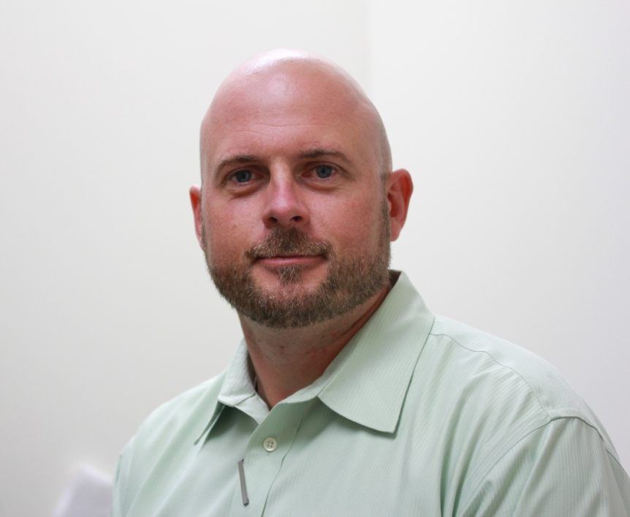

Candidate Name: Christian G. Westring

Organization: NMS Labs

Address: 2300 Stratford Avenue, Willow Grove, PA 19090

Phone Number: (215)366-1380

E-mail: christian.westring@nmslabs.com

Education: Ph.D.

Employment Experience: DNA Technical Leader, Department of Forensic Genetics, Institute for Legal Medicine, Copenhagen, Denmark; DNA Technical Leader, Department of Forensic Biology, NMS Labs; Laboratory Director, Criminalistics, NMS Labs.

Prior ASCLD experience (previous Board member, committee member, meeting volunteer, etc.): 2014 and 2015 meeting planning committees

If elected, I am interested in working on the following ASCLD issues/committees: Education & Training Committee, Forensic Research Committee, Membership Committee, and Symposium Planning Committee

As a member of the Board, you may be asked to represent ASCLD at speaking engagements or develop written statements on behalf of the Board. How would you describe your ability to communicate ideas verbally and in writing? As practitioners in the forensic community, it is critical that we develop the requisite skills necessary to disseminate both written and oral presentations to a varied audience. In particular, laboratory managers are tasked with delivering key messages both internal and external to ones parent organization. These may come in the form of forensic reports, quality statements, or other public announcements that necessitate confidence and clarity in delivery. Considering the impact we have within the forensic community, our local government(s), and/or on a national plan, the effectiveness of our delivery is paramount. Understanding the value in strong leadership, I continue to hone and develop these skills to confidently and effectively deliver both written and verbal presentations to my target audience.

How committed are you to serving on the ASCLD board? What skills will you bring to the table? As an active contributor to the forensic community on several fronts, I’m prepared to serve on the ASCLD Board of Directors. Given its history, ASCLD continues to play an integral role in education, leadership, and quality in the forensic sciences. With more than 15 years of experience in forensic science, I’ve held a wide range of positions in academia, public service, and private sector forensics. These experiences have provided the opportunity to explore some of the unique challenges we face as the development of the forensic sciences continue to progress into the 21st century. As a result, I am confident that my experiences at home, and abroad, will supplement the Boards mission as it continues to deliver on its core values.

What role should ASCLD play in developing a strong future for forensic science laboratories? Given the changing climate within the forensic sciences, ASCLD should continue to play a strong role education, training, leadership, and quality. With formation of the newly formed OSACs, ASCLD should play an integral role in supporting the mission to develop scientifically based standards within the each discipline in the forensic sciences. While the development of standards may not be with the core objectives of the ASCLD organization, the forensic community will look for strong leadership as we transition into the next generation of forensic sciences. This will not only strengthen the forensic community as a whole, but also emphasize the need for continuous improvement. As this becomes a new core objective for the community, ASCLD’s historical role in training and education will become ever more prevalent.

