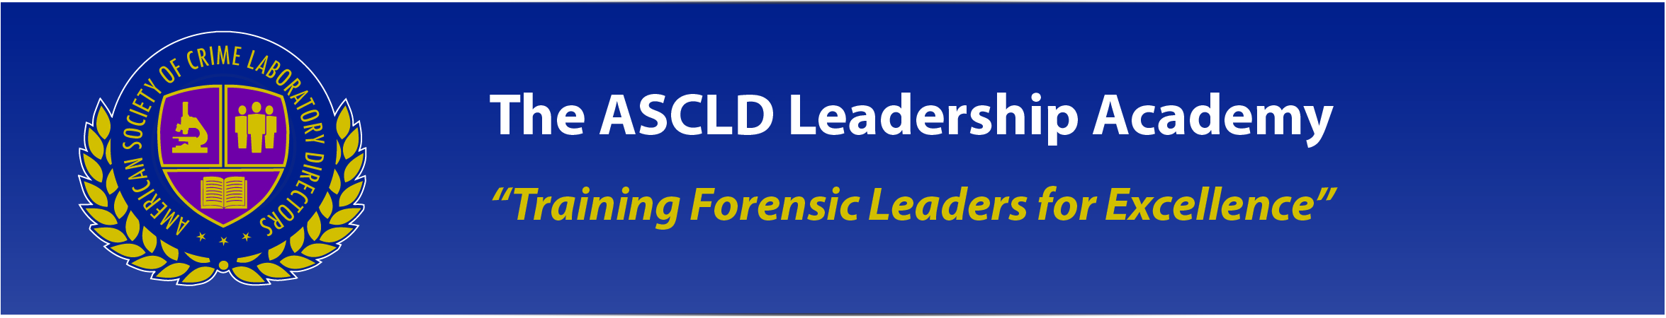

ASCLD Leadership Academy
Request for Instructors

Summary

The American Society of Crime Laboratory Directors (ASCLD) is now accepting applications from members interested in serving as instructors for the upcoming ASCLD Leadership Academy in 2015.

Background

After a resounding success in 2014, the 2nd ASCLD Leadership Academy will be held in early 2015. The Academy will again target new supervisors in the forensic science field or supervisors who have previously had limited opportunity for structured forensic management education and training.

Academy instruction will be delivered via webinar-style online sessions during the months of February, March, and April and will conclude with live, instructor-led training at the 2015 ASCLD Symposium in Washington, DC. Each month of web-based instruction will be centered on a topical theme and will include 4, weekly 2-hour sessions. The in-person “Capstone” sessions in Washington will incorporate the key learning themes from each monthly topic.

Tentative Scheduling and Topics

 | January/February | February/March | March/April | April
 | Leadership  (online) | Communication  (online) | Human Resources / Legal Issues  (online) | CAPSTONE  (in person)
Week 1 | Ethics of Leadership | Communication Styles | Human Resources Rules of the Road | 2-day workshop April 26 - 27 covering key management academy topics at the 2015 ASCLD Symposium in Washington, DC
Week 2 | Team Building | Effective Communication | Personnel Law (EEO, FLSA, FMLA, termination)
Week 3 | Conflict Management | Crucial Conversations | Effective and legal interview questions and employee evaluation criteria
Week 4 | Operational Excellence | Intro. to Media Relations | On-boarding of new employees
Details

Instructors are being sought for each of the three topical monthly themes: Leadership, Communication, and Human Resources/Legal Issues. A tentative schedule of preferred weekly courses has been developed, however the ASCLD Training and Education committee will work with the selected instructors for each theme and alter the weekly session content if necessary.

Individual Instructor responsibilities
- Prepare and deliver 4, weekly online sessions (2 hours each) centered on a monthly theme.
  - Sessions should be developed to deliver maximum value to a new supervisor with little or no previous supervisory experience.
  - Sessions should be focused, as much as possible, on supervision/management within the context of a forensic science laboratory.
  - The weekly session content provided on page one in the Tentative Schedule is preferred.
  - The ASCLD Training and Education committee will provide training on the platform selected to deliver on-line training and will assist the instructor in loading and managing the online web-based system (AdobeConnect, WebEx, or similar). At least one person from the committee will be online and available for technical assistance during each session.

- Prepare and deliver a 4-hour, hands-on, capstone session at the 2015 ASCLD Symposium in Washington, DC.
  - The session should focus on practical exercises and hands-on interaction that incorporates all the content from the 4 online sessions.

Benefits
As a thank you to the selected instructors, ASCLD is pleased to cover the following expenses related to the 2015 ASCLD Symposium in Washington, DC:
- Registration for the symposium
- Roundtrip airfare to the symposium
- 3 nights of lodging at the symposium hotel

Interested parties are encouraged to complete the attached application and return it via email to Andrea Swiech, ASCLD Training & Education co-Chair, at andrea.swiech@osbi.ok.gov.

Applications must be received by end-of-business Friday, November 21, 2014.

ASCLD Leadership Academy

Instructor Application

(Please attach separate pages, as necessary)

Name: _____________________________ Title: ________________________________
Agency: ____________________________________________________________________
Address: ___________________________________________________________________
Phone: ____________________________ Email: _______________________________

1. For which general theme would you like to apply?

□ Leadership □ Communication □ Human Resources/Legal Issues

2. Please, describe your prior management experience in forensic science.

3. Please, describe your prior teaching experience on the topic for which you wish to apply as an instructor.

4. Please, describe any experience you have delivering web-based instruction via programs like AdobeConnect, WebEx, or similar platforms.

5. Four weekly topics for each monthly theme have been provided in the Call for Instructors. For the general theme that you wish to apply for as an instructor, in brief, what are 2 or 3 main points of instruction that you would deliver on each weekly topic. If you were to suggest a different weekly topic in your particular theme of interest, what would it be and what are 2 or 3 main points of instruction that you would deliver?

6. For the general theme that you wish to apply for as an instructor, please, describe your ideas on potential hands-on instruction/activities that you would deliver or lead at the April 2015 ASCLD symposium in Washington DC.

7. Please, provide the name and contact information of 2 individuals that can provide the committee feedback regarding your qualifications as an instructor.

Please, submit completed applications along with a current CV to Andrea Swiech at andrea.swiech@osbi.ok.gov.

Applications must be received by end-of-business Friday, November 21, 2014.

