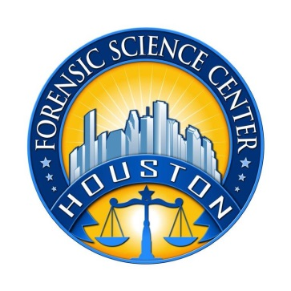 | Houston Forensic Science Center, Inc.  1200 Travis St., 20th Floor  Houston, TX 77002  TRAINING SPECIALIST

Houston Forensic Science Center (HFSC) is an independent organization created by Houston Mayor Annise Parker and the Houston City Council to provide forensic science services formerly delivered by the Houston Police Department. HFSC has been officially registered as a Texas Local Government Corporation* since June 26, 2012.

HFSC is now seeking a full-time Training Specialist. HFSC offers a competitive salary and benefit package that is commensurate with experience.

POSITION SUMMARY
Under the direction of the training directors, the Training Specialist is responsible for performing designated internal and external forensic training activities of HFSC. Specific duties of the Training Specialist may include, but are not limited to, the following:
- Work with the training directors in planning, directing and implementing internal and external programs.
- Form training objectives, create strategies, and execute plans of the Forensic Training department.
- Write curricula and conduct training sessions.
- Provide customer service and continuous quality improvement for internal and external customers.
- Work with other managers of the Forensic Analysis Division, the administrative offices, and the Quality Division to ensure that required training objectives are being met.
- Work with the training directors to ensure that the budget for the department is being adequately utilized and reported.
- Plan with external trainers seminars that benefit the HFSC staff.
MINIMUM EDUCATION REQUIREMENT
A Bachelor’s degree in a related Science is required. A degree in another field may be considered if the forensic background experience is extensive. A Master’s degree is preferred.

MINIMUM EXPERIENCE REQUIREMENT
A minimum of five years of experience in a forensic lab environment is required. A minimum of two years of proven experience in the training of forensic science to small and large groups is required.

KNOWLEDGE AND SKILLS REQUIREMENT
- Proven expertise in Microsoft Office applications, specifically Word, Excel, PowerPoint and Outlook, is required. Experience in related software preferred.
- Certification in a forensic science discipline is preferred.
- Proven public speaking skills are required.

CONTACT INFORMATION
Interested applicants meeting the job qualifications should forward their résumé and cover letter to hr@houstonforensicscience.org.

Houston Forensic Science Center, Inc., is an Equal Employment Opportunity Employer

*A “local government corporation” is created to aid and act on behalf of one or more local governments to accomplish any governmental purpose of those governments.

