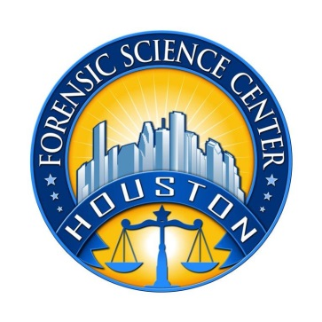
Houston Forensic Science Center, Inc.
1200 Travis St., 20th Floor
Houston, TX 77002
Forensic Analyst-Toxicology

Houston Forensic Science Center is an independent organization created by Houston Mayor Annise Parker and the Houston City Council to provide forensic science services formerly delivered by the Houston Police Department. HFSC. has been officially registered as a Texas Local Government Corporation* since June 26, 2012.

The Houston Forensic Science Center is now recruiting for a full-time Toxicology Forensic Analyst.

POSITION SUMMARY
The Toxicology Analyst will perform toxicology analyses for the Houston Forensic Science Center. The successful candidate will independently perform chemical analyses of human fluids and tissues in postmortem, human performance (DUI), drug facilitated sexual assaults and other criminal cases using chemical and instrumental methodologies, prepare reports on findings for use in the criminal justice system, and provide court testimony on analytical results. Experience with volatile analysis is required.

MINIMUM EDUCATIONAL REQUIREMENTS
The position requires a Master’s degree in Chemistry, Biochemistry, or related Biological Science is required. PH.D is a plus. Thirty hours of chemistry are required.

MINIMUM EXPERIENCE REQUIREMENTS
Minimum of 2 years of work experience using advanced laboratory equipment, instrumentation in a forensic laboratory in the area of toxicology. Proven experience presenting testimony in a court of law as an expert witness

KNOWLEDGE AND SKILL REQUIREMENTS
- Comprehensive knowledge of principles, practices, and terminology of analytical chemistry as it applies to the field of forensic toxicology.
- Comprehensive knowledge of current developments in the field of Toxicology; through knowledge of modern laboratory principles.
- Comprehensive knowledge of pharmacologic and toxicological principles as applied to forensic toxicology analysis and interpretation.
- Excellent verbal and written communication skills
- Ability to work well with all levels of employees and outside contacts
- Demonstrated skills at effective project management
- Demonstrated ability to think critically, troubleshoot effectively and make timely and sound decisions
- Demonstrated ability to work well with details
- Proven expertise in Microsoft Office applications

CONTACT INFORMATION
Interested applicants meeting the job qualification can forward their resume and cover letter to hr@houstonforensicscience.org

Houston Forensic Science Center Inc. is an Equal Employment Opportunity Employer

*A “local government corporation” is an independent organization that includes the participation of one or more governmental agencies.

