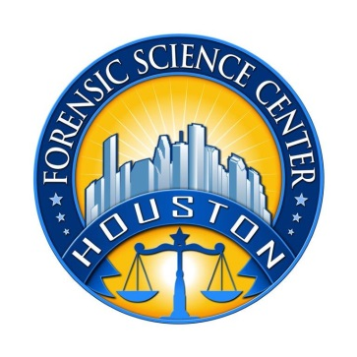

Houston Forensic Science Center, Inc.
1200 Travis St., 20th Floor
Houston, TX 77002

CRIME SCENE INVESTIGATOR
Houston Forensic Science Center (HFSC) is an independent organization created by Houston Mayor Annise Parker and the Houston City Council to provide forensic science services formerly delivered by the Houston Police Department. HFSC has been officially registered as a Texas local government corporation* since June 26, 2012.

HFSC is now seeking a full-time Crime Scene Investigator for the Evidence Processing Division. The successful applicant must be willing to work an evening or night shift.

POSITION SUMMARY
The Crime Scene Investigator is responsible for identifying, documenting, collecting, and interpreting evidence from complex and high-profile crime scenes, typically in conjunction with an ongoing police investigation. This position responds to assignments twenty-four hours a day, seven days a week. Principal responsibilities of the position include, but are not limited to, the following:
- Process complex crime scenes, including the identification, documentation, collection, preservation, and submission of evidence.
- Generate detailed offense reports.
- Photograph and videotape major crime scenes.
- Produce detailed crime scene diagrams.
- Respond to call-ups during off-duty hours.
- Complete specialized classroom and on-the-job training as required.
- Perform other duties as assigned.

MINIMUM EDUCATION REQUIREMENT
A bachelor’s degree in a related field of science is required; experience may be considered in lieu of the degree on a 2-for-1 basis (i.e., two years of experience for each year of required education).
MINIMUM EXPERIENCE REQUIREMENT
A minimum of two years applicable experience is required. An advanced degree with relevant experience in a lab or related environment may be considered as equivalent experience.

KNOWLEDGE AND SKILLS REQUIREMENT
- Excellent interpersonal skills, with the demonstrated ability to interact effectively with citizens or family members who are experiencing traumatic events such as a horrific crime
- Ability to work unsupervised or in a small group after the completion of appropriate training, completing complex tasks and procedures with minimal or no guidance
- Exceptional written and verbal communication skills
- Possession or ability to obtain a Texas driver’s license to operate a vehicle loaded with Crime Scene Unit equipment and tools
- Willingness to test for and obtain certification as a “Certified Crime Scene Investigator” upon completion of one (1) year of service in the Crime Scene Unit
- Proven expertise in Microsoft Office applications, specifically Word, Excel, PowerPoint, and Outlook, and Microsoft’s cloud-based service, SharePoint, is required. Working knowledge of a Laboratory Information Management System (LIMS) and Microsoft Access is a plus.
- Willingness to work extended hours with little or no advance notice.

- Ability to meet the following physical requirements with or without accommodations:
  - Ability to stand and walk around for extended periods of time
  - Ability to complete tasks regardless of the weather or temperature
  - Ability to complete tasks regardless of foul odors or insect activity
  - Ability to lift and carry, push or pull up to 150 lbs.

CONTACT INFORMATION
Interested applicants meeting the job qualifications should forward their résumé and cover letter to hr@houstonforensicscience.org.

Houston Forensic Science Center, Inc., is an Equal Employment Opportunity Employer

*A “local government corporation” is created to aid and act on behalf of one or more local governments to accomplish any governmental purpose of those governments.

