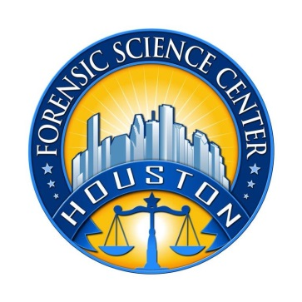

Houston Forensic Science Center, Inc.
1200 Travis St., 20th Floor
Houston, TX 77002

FORENSIC ANALYST –
AUDIO/VIDEO

Houston Forensic Science Center, Inc. (HFSC), is an independent organization created by Houston Mayor Annise Parker and the Houston City Council to provide forensic science services formerly delivered by the Houston Police Department. HFSC has been officially registered as a Texas Local Government Corporation* since June 26, 2012.

HFSC is now seeking a full-time Forensic Analyst in the Audio/Video Unit. HFSC offers a competitive salary and benefit package that is commensurate with experience.

POSITION SUMMARY
The successful candidate will be responsible for forensic examination of audio and video evidence. The basic responsibilities of the analyst include but are not limited to:
- Analysis of audio and videotapes and still photographs and other evidence, whether analog or digital in nature used in criminal investigations.
- Specialized technical work in the clarification, enhancement, repair, reconstruction, and authenticating of audio and video evidence
- Document retrieval and processing of audio-video evidence
Decode, isolate, capture, examine, and clarify audio signals and video images for evaluation in support of criminal investigations and/or prosecution.
- Troubleshoot and identify adjustment, repair, and/or replacement needs for malfunctioning or non-working audio/visual systems and equipment.
- Produce reports and testify to the findings of analysis.

MINIMUM EDUCATIONAL REQUIREMENTS
Bachelor’s degree in the physical sciences, criminalistics, or closely related field or equivalent experience. A graduate degree is strongly preferred.

MINIMUM EXPERIENCE REQUIREMENTS
A minimum of five years of forensic laboratory experience in audio/video enhancement or forensics digital imaging, demonstrating state of the art proficiency in analysis and enhancement of audio and video tape evidence and digital imaging analysis

KNOWLEDGE AND SKILL REQUIREMENTS
- Demonstrated skill in oral and written communication.
- Additional specialized course(s) in Basic Forensic Video Analysis (LEVA) is preferred.
- Demonstrated skills in handling multiple tasks and prioritizing work assignments.
- Demonstrated ability to effectively handle conflict and uncertain situations.
- Demonstrated ability to work with frequent interruptions and changing priorities.
- Demonstrated ability to establish and maintain effective communications and working relationships with fellow employees, internal customers, and external customers.
- Ability to lift computers that can weigh up to 50 lbs.

CONTACT INFORMATION
Interested applicants meeting the job qualifications may forward their résumé and cover letter to hr@houstonforensicscience.org.

Houston Forensic Science Center, Inc., is an Equal Employment Opportunity Employer

*A “local government corporation” is created to aid and act on behalf of one or more local governments to accomplish any governmental purpose of those governments.

