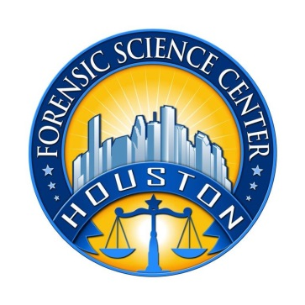

Houston Forensic Science Center
1200 Travis St., 20th Floor
Houston, TX 77002

FORENSIC ANALYST—BIOLOGY

Houston Forensic Science Center (HFSC) is an independent organization created by Houston Mayor Annise Parker and the Houston City Council to provide forensic science services formerly delivered by the Houston Police Department. HFSC has been officially registered as a Texas local government corporation* since June 26, 2012.

Houston Forensic Science Center is now seeking a full-time Forensic Analyst in the Biology section.

POSITION SUMMARY
Under the direction of the Manager of Forensic Biology, the analyst:
- Performs routine to moderately complex analysis of biological samples
- Prepares accurate and precise notes and technical reports
- Maintains and calibrates scientific instruments and follows quality control measures to ensure instruments meet required performance standards
- Provides technical assistance to police officers, members of the district attorney’s office, and other members of law enforcement agencies and the criminal justice community
- Testifies as an expert witness regarding the scientific conclusions drawn from analysis
- Partners with management and other staff to ensure other tasks are completed as assigned

MINIMUM EDUCATIONAL REQUIREMENTS
The position requires a bachelor’s degree in biology, biochemistry, genetics, forensic sciences or a closely related science field from an accredited college/university (transcripts required). Subjects providing a basic understanding of forensic DNA analysis, as well as courses or training in statistics and population genetics as they apply to forensic DNA analysis, are strongly preferred. A skills assessment will be given to evaluate knowledge level.

MINIMUM EXPERIENCE REQUIREMENTS
Minimum of one year of experience working in a DNA/biology forensic environment is required. Previous analytical experience in a forensic DNA laboratory, specifically with GlobalFiler analysis, is strongly preferred. Proven expertise in Microsoft Office applications is a plus.

KNOWLEDGE AND SKILL REQUIREMENTS
- Excellent verbal and written communication skills
- Ability to work well with all levels of employees and outside contacts
- Demonstrated ability to think critically, troubleshoot effectively and make timely and sound decisions
- Demonstrated ability to work well with details

CONTACT INFORMATION
Interested applicants meeting the job qualifications may forward their résumé and cover letter to hr@houstonforensicscience.org.

Houston Forensic Science, Inc., is an Equal Employment Opportunity Employer

* *A “local government corporation” is created to aid and act on behalf of one or more local governments to accomplish any governmental purpose of those governments.

