Members of the ASCLD Board of Directors are elected by the membership for terms having a specified length. Board seats are voluntary and are critical to the successful operation of the association. Committees and committee chairpersons are established to ensure that specific functions and member services are completed appropriately.
Photo | Member | Board Position | Lab System
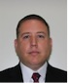 | Adam Becnel | Sponsorship Committee Chair | Louisiana State Police
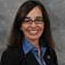 | Kris Cano | Ethics & Bylaws Committee Chair | Scottsdale Police Department
 | Sabrina Cillessen | Communication Committee Chair | Virginia Department of Forensic Science
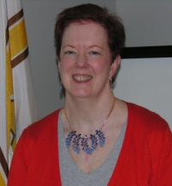 | Cecilia Doyle | Secretary | Illinois State Police
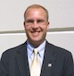 | Matthew Gamette | Treasurer | Idaho State Police
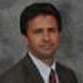 | Jay Henry | Past - President | Utah Department of Public Safety
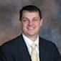 | Brady Mills | President | Texas Department of Public Safety
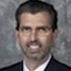 | Jeff Salyards | Membership Committee Chair | Defense Forensic Science Center
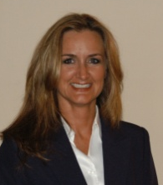 | Andrea Swiech |  | Oklahoma State Bureau of Investigation
 | Jeremy Triplett | Training & Education Committee Chair | Kentucky State Police
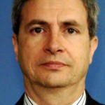 | Ray Wickenheiser |  | New York State Police Crime Laboratory
 | Jody Wolf | President Elect | Phoenix Police Department

