Be sure to not miss this opportunity! Many registrants will be seeking information about products and services necessary to ensure the on-going quality of their laboratories. They look to you for ideas, answers and resources. Exhibiting at the ASCLD symposium will provide you with the access to the forensic laboratory decision makers and appropriations managers. These are the people that approve purchase requests within the laboratory. Areas of interest include:

Trace evidence, Computer Applications, Laboratory Management Systems (LIMS), Toxicology, Microscopy, Lab Design, Document Examination, Crime Scene Investigation, Accreditation Programs, Computer Forensics, DNA Analysis, Drug Testing, Toxicology, Firearms, Tool Marks, Laboratory Safety, Fire Debris Analysis, Latent Fingerprints, Evidence Storage, Outsourcing Vendor Services, Data Storage, Management Resources, Imaging Technology, Calibration Services, Quality Assurance, and Books and Literature.

Please consider joining us as a vendor for the 41st Annual meeting of the American Society of Crime Lab Directors. We will be hosting the meeting at the Double Tree Resort located in Paradise Valley – Scottsdale, AZ.

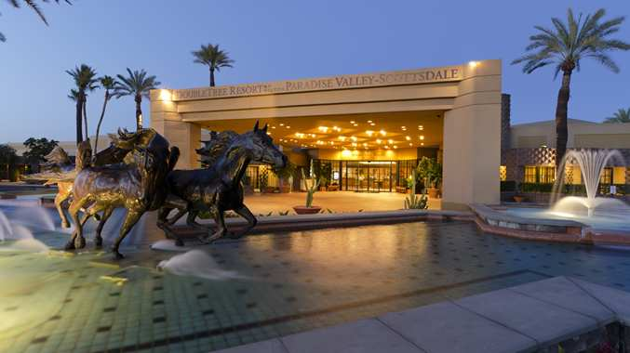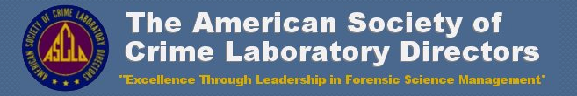

Exhibit in Scottsdale, AZ (May 4-8, 2014)

For more information, please contact Jay Henry at [Jhenry@utah.gov](mailto:Jhenry@utah.gov)

# ASCLD 2014