Candidate Name:
Timothy P. Scanlan, Ph.D.

Organization:

Jefferson Parish Sheriff’s Office

Address:
1233 Westbank Expressway, Bldg. G Harvey, LA 70058

Phone: 504-875-3895 (Office)
504-655-2623 (Cell)

E-mail: scanlan_tp@jpso.com

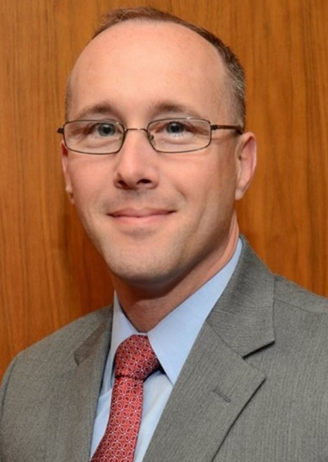

Education:

2015: Doctor of Philosophy (Ph.D.) in Public Policy and Administration with a specialization in Homeland Security: Policy and Coordination, Walden University

Dissertation: Influences of CSI Effect, Daubert Ruling, and NAS Report on

Forensic Science Practices

2003: Master of Science in Forensic Science Degree (M.S.F.S.), Florida International

University
Thesis: The Corrosive Effect of Blood Regarding the Forensic Identification of
Fired Projectiles

Employment Experience:
2016 to Present: Jefferson Parish Sheriff’s Office: Technical Services Bureau Chief

2011 to 2016: Jefferson Parish Sheriff’s Office: Laboratory Services Commander

2009 to 2011: Jefferson Parish Sheriff’s Office: Crime Laboratory Director

2006 to 2009: Jefferson Parish Sheriff’s Office: Assistant Crime Laboratory Director

1998 to 2006: Jefferson Parish Sheriff’s Office: Forensic Scientist

Prior ASCLD experience (previous Board member, committee member, meeting volunteer, etc.):
2014: Instructor for the American Society of Crime Laboratory Directors (ASCLD) Leadership Academy, created and instructed the curriculum in Leadership Communication for Crime Laboratory Administrators

2015: Instructor for the American Society of Crime Laboratory Directors (ASCLD) Leadership Academy: Leadership Communication for Crime Laboratory Administrators

2016: ASCLD’s Training and Education Committee

Instructor for the American Society of Crime Laboratory Directors, co-created and instructed ASCLD Train the Directors Webinar Series: Overview of Firearms Examination for the Crime Laboratory Administrator

Instructor for the American Society of Crime Laboratory Directors (ASCLD) Leadership Academy: Leadership Communication for Crime Laboratory Administrators

National Forensic Science Academy Working Group (ASCLD Project Team)

If elected, I am interested in working on the following ASCLD issues/committees:

Training and Education Committee

Nominations Committee

Communication Committee

As a member of the Board, you may be asked to represent ASCLD at speaking engagements or develop written statements on behalf of the Board. How would you describe your ability to communicate ideas verbally and in writing?

In addition to teaching “Leadership Communication” for the ASCLD Leadership Academy, I also act as the Community Liaison for my agency, where I am tasked with communicating its message to the members of the criminal justice system, civic groups, and business community. This allows me to have a positive influence on how forensic science is perceived by the citizens I serve on a daily basis and play an active role in spreading the message of justice through sound science across the country.

As a professor of forensic science for Loyola University of New Orleans, I have written the curriculum for its graduate, undergraduate, and certification programs. Writing meaningful curriculum is important, because it shapes the academic foundation for future forensic scientists. Additionally, I have played a role in authoring legislation in my state that has led to sound laws that effect forensic analysis.

Both academic and legal writing will become increasingly important, as we set the agenda for promoting best practices in forensic science and demonstrate the legally and scientifically sound foundation from which crime laboratories provide analysis.

How committed are you to serving on the ASCLD board? What skills will you bring to the table?

I believe that everyone running for the board is committed to not only ASCLD, but the betterment of forensic science, as a whole. In addition to the ability to promote effective leadership communication, I possess a unique ability to connect members of the criminal justice system and academic community. In order to establish a sound basis for the effective application of science within the criminal justice system, we must promote best practices and defend the academic foundation of the science. I have played a role in these efforts at the local, state, and national level.

What role should ASCLD play in developing a strong future for forensic science laboratories?

ASCLD must act as a leader in developing a strong foundation for both crime laboratories and independent experts. Forensic science extends beyond the walls of the crime laboratories we are charged with leading. We must ensure that all members of the forensic science community provide accurate analysis. Members of the board should promote best practices across all disciplines and work to ensure that all experts conduct accurate analysis and provide unbiased testimony. The future of forensic science must be grounded in providing impartial, accurate, and scientifically sound analysis, across the spectrum of the criminal justice system.

