Candidate Name:

John T. Griffin

Organization:

Virginia Department of Forensic Science-Northern Laboratory

Address:

10850 Pyramid Place

Manassas, Virginia 20110

Phone: 703-335-8100

E-mail: john.griffin@dfs.virginia.gov

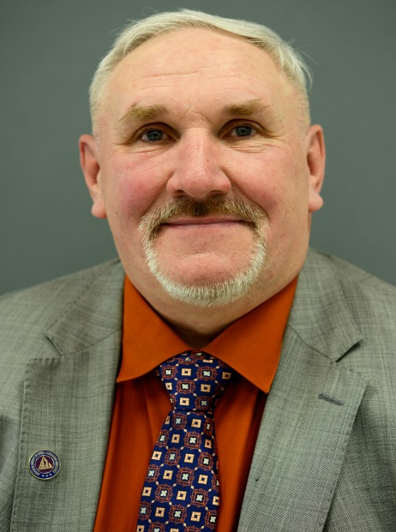

Education:
Bachelor of Science Degree in Biology, Graduate work in Biology and Chemistry

Employment Experience:

Employed as a Forensic Scientist with the Virginia Department of Forensic Science assigned to the Controlled Substances section for 23 years and functioned as a primary operator for GC/MS instrumentation, was a group supervisor in the Controlled Substances section in the Central Laboratory in Richmond and returned to the Northern Laboratory to manage the Controlled Substances section as the section supervisor. I became the Director of the Northern Laboratory in August of 2011.

Prior ASCLD experience (previous Board member, committee member, meeting volunteer, etc.):
I served on the symposium planning committee for the 2015 symposium in Washington, D.C. I am currently serving on the Education and Training and Membership committees.

If elected, I am interested in working on the following ASCLD issues/committees:

I would like to continue working on the Education and Training and the Membership committees and lending my help to any other needs of ASCLD.

As a member of the Board, you may be asked to represent ASCLD at speaking engagements or develop written statements on behalf of the Board. How would you describe your ability to communicate ideas verbally and in writing?
Over the last 27 years in working in the field of forensic science, I have developed strong skills is communicating both verbally and in writing. Preparation of performance evaluations, requests for training, developing employee work profiles, technical procedure drafting and other written tasks usually come easy to me. My educator experience has allowed me to hone my abilities in providing presentations to many different types of groups with varying sizes and interests.

How committed are you to serving on the ASCLD board? What skills will you bring to the table?

I am very committed to serving on the ASCLD board. I have become quite involved in the committees that I serve on and would like to offer my experience and expertise to the Board to further its mission. I am a team player, dedicated to the tasks that I am assigned and bring almost 30 years of experience from the bench level through the management levels of the crime laboratory. These are the skills and perspectives that I can offer.

What role should ASCLD play in developing a strong future for forensic science laboratories?

In helping to develop a strong future for forensic science laboratories, ASCLD does and should continue to play a pivotal role in making sure that laboratories across the United States and abroad will be able to have an organization that will provide support to them, answer questions and provide sound guidance as new policies and procedures are being developed. It is also important that ASCLD maintain and even strengthen its involvement with the National Commission on Forensic Science and the OSAC to make sure that the changes that are taking place are communicated to laboratories and that the laboratory has a voice in offering opinions and suggestions as this process moves forward. It is a critical time for forensic laboratories, and ASCLD must continue to provide support and remain as an advocate for laboratories. I welcome the opportunity to be able to help ASCLD continue in this extremely important mission.

