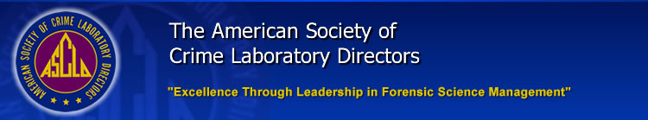

ASCLD BOARD OF DIRECTORS
2015-2016 Strategic Plan
- Develop production guidelines for the ASCLD BOD deliverables.
  - Update the Administrative Manual with a checklist for due dates for various deliverables:
    - Committee Meetings – Monthly
    - Strategic Plan – late winter/early spring, before the symposium
    - Symposium Registration – no later than January 15
    - BOD Teleconferences – Monthly
    - Administrative Manual Review – Publish by April 15
    - Executive Education Digest – Publish by April 1
    - New Meeting Site Announcement (3 years out) – By December 31
    - Survey Membership – Annually at the symposium

- Forensic Research Committee
  - Populate validation portal
  - Develop opt-in notifications of new validation documents for members
  - Evaluate model program for Rapid DNA implementation

- Ad-Hoc Policy Committee
  - Test the ASCLD policy flow chart
  - Provide comment to both the National Commission and OSAC
  - Publish policy statements in 2015-2016 on:
    - Grant reform
    - Who is a forensic service provider (FSP)
    - Update Rapid DNA
    - Certification
    - Rape kit position statement
    - Commission priorities

- Training and Education
  - Webinar series for pharmacology training for toxicologists and drug chemists
  - Webinar on cross training laboratory directors in other disciplines
  - Leadership Academy
    - 100 series
    - Arnold Foundation opportunities

- Partnerships
  - Seek out corporate sponsorships for ASCLD symposium
  - Arnold Foundation – grants
  - NIJ – Cohost the Grant meeting, SAFER Committee, submitted rape kit backlog, grant reform input
  - FBI/CJIS – Rapid DNA and expanding membership

- International
  - Stand-alone website
  - Minimum Requirements Documents (MRDs) – translate completed MRDs (DNA, Crime Scene and Drugs) into French
  - Educate and inform membership about ASCLD international activity

- Standards
  - TC 272
    - Finish DNA standard
    - Monitor new documents coming out
    - Educate and inform the membership

