2015 ASCLD Board of Directors Candidate Questionnaire
(Responses do not need to remain at 1 page)

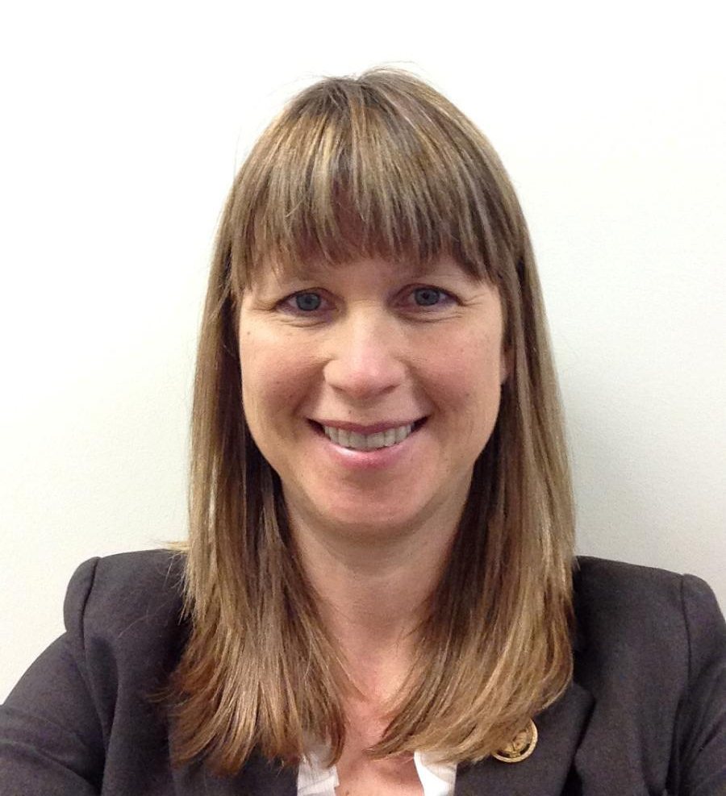

Candidate Name: Kristine (Kris) Deters

Organization: MN Bureau of Criminal Apprehension Forensic Science Service

Address: 1430 Maryland Ave E., St. Paul, MN 55106

Phone Number: 651-793-2994 (w) and 651-587-7795 (c)

E-mail: Kristine.deters@state.mn.us

Education:
University of Minnesota - Duluth, MN
Dates attended: 1993 - 1995
M.S. Degree - Chemistry, Concentration: Biochemistry

University of Minnesota - Duluth, MN
Dates attended: 1989 - 1993
B.S. Degree – Biology and Chemistry

North Carolina State University – Raleigh, NC
Date class taken: Fall 2001
Class: Statistical Genetics for Forensic Scientists

Employment Experience:

MN BCA Forensic Science Service, 11/1999 to present

Forensic Science Supervisor – 1/2009 to present
Forensic Scientist 3 – 3/2004 – 1/2009
Forensic Scientist 2 – 11/10/99 to 3/2004
Principle Duties:
Supervise Nuclear DNA Casework section – 12 direct reports and casework manager for 11 additional DNA scientists
Supervise Crime Scene Team Program (appointed 8/2013) – 1 direct report and technical manager for 20 additional scientists
To act as spokesperson for technical information and laboratory activities for clients and the public
To assure quality forensic examinations are provided to LE community
To plan, coordinate, evaluate and implement all technical programs in the biology and crime scene sections
To manage the research, validation, technical implementation and quality control of significant new technologies being developed within the biology and crime scene sections
To assure that the results and interpretation of nuclear DNA analyses and crime scene response reports provided to the criminal justice system are accurate and timely
To act as a lead auditor for internal audits of the laboratory and prepare reports and recommendations to improve the quality operations of the laboratory
To evaluate, interview and make recommendations to laboratory management concerning the hiring of new staff, promotion of current staff and remedial actions that may be needed for staff
Currently qualified DNA scientist
Past Duties:
DNA Technical Leader 1/2010 to 7/2010, 2/2011 to 5/2011
Acting Supervisor 4/2006 to 10/2006 and 6/2008 to1/2009
Training coordinator/ casework lead worker to the Biology Section (‘04-‘09)
Crime Scene Team Leader
DNA Technical Leader for South Dakota Forensic Laboratory (2001-2004)

Washington State Patrol Crime Laboratory, 10/23/95 to 10/15/99
Forensic Scientist 1, 2, 3
Duties:
analyze evidence including DNA (RFLP and STR) analysis, biochemical analysis (serology) and chemical analysis of controlled substances
Develop and validate methods of analysis (DNA STR analysis)
Provide training for other scientists and technicians

Prior ASCLD experience (previous Board member, committee member, meeting volunteer, etc.): 2015 ASCLD Symposium Planning committee member

If elected, I am interested in working on the following ASCLD issues/committees:

Training and education committee – the quality of forensic science examinations is directly related to the qualifications of practitioners and the laboratory’s quality program. Also, as managers, it is beneficial to our organizations to have educated candidates for employment. I am interested in both educational opportunities at the college level, as well as continuing education and training for practitioners and managers.

I am also interested in working on any initiatives involving sexual assault kit processing and Rapid DNA technology implementation. These topics are of great interest to the law enforcement and forensic communities, as well as the general public. The ability to provide quality and rapid testing services to all victims should be a priority for forensic science organizations.

As a member of the Board, you may be asked to represent ASCLD at speaking engagements or develop written statements on behalf of the Board. How would you describe your ability to communicate ideas verbally and in writing?

I enjoy speaking and writing about issues involving forensic science. I can clearly convey information to a technical audience or present my ideas to a general audience in a manner that is easily understood.

How committed are you to serving on the ASCLD board? What skills will you bring to the table?

I am very committed to serving on the ASCLD board. I have long been serving the citizens of Minnesota in my capacity as a forensic scientist and supervisor. Now I would like to use my skills and knowledge to serve the forensic community though participation in ASCLD’s activities. I have the leadership skills, passion and energy to complete the tasks required of board members.

I have been employed as a forensic scientist for almost 19 years combined at two large state forensic laboratory systems, the Washington State Patrol and the Minnesota Bureau of Criminal Apprehension Forensic Science Service (BCA). The last six years have been as a supervisor at the BCA in the DNA section and also supervising the Crime Scene discipline for the last 1.5 years. I am familiar with many of the forensic disciplines, as during my career, I have worked in controlled substances analysis, serology, DNA testing and crime scene processing. I have led the DNA section to incorporating a greater level of automation in order to respond to the increased demands for DNA testing of all crimes. I was an ASCLD/LAB Legacy auditor, am a trained ASCLD/LAB International assessor and plan to do assessments for ASCLD/LAB. I have been a lead DNA auditor for NFSTC and have conducted external and internal QAS audits. These experiences demonstrate that I have the skills to be a leader for ASCLD and the follow-through to complete the necessary tasks.

What role should ASCLD play in developing a strong future for forensic science laboratories?

ASCLD is uniquely positioned to influence the quality and effectiveness of forensic testing both in the United States and the global community. ASCLD can ensure a strong future for forensic science laboratories by continuing to play an active role in (1) the education and training of practitioners, managers and leaders of forensic science organizations, (2) providing expertise for legislative initiatives at the state and national level, (3) supporting efforts for standardization of forensic analysis and accreditation of testing laboratories and (4) promoting the exchange ideas and information worldwide.

