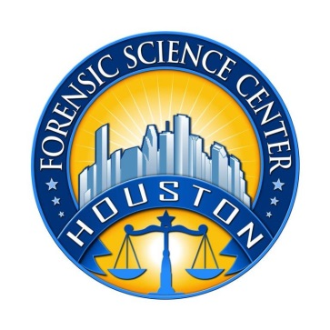
Houston Forensic Science Center, Inc.
1200 Travis St., 20th Floor
Houston, TX 77002

DIRECTOR
METHODS AND VALIDATION

Houston Forensic Science Center, Inc. (HFSC), is an independent organization created by Houston Mayor Annise Parker and the Houston City Council to provide forensic science services formerly delivered by the Houston Police Department. HFSC has been officially registered as a Texas Local Government Corporation* since June 26, 2012.

HFSC is now seeking a full-time Director of Methods and Validation. HFSC offers a competitive salary and benefit package that is commensurate with experience.

POSITION SUMMARY
The Director of Methods and Validation will direct and implement methods, validation and research policies, objectives, and initiatives for the corporation. These efforts will include initiatives in all forensic discipline areas of the corporation. As the first director for a new service line, the successful applicant will ensure methods, validation and research activities support and enhance the corporation’s competitive position and viability in the field of forensic services.

MINIMUM EDUCATION REQUIREMENTS
Requires a master’s degree, with a Ph.D. strongly preferred. Familiarity with a variety of the field's concepts, practices, and procedures is required.

MINIMUM EXPERIENCE REQUIREMENTS
Minimum of ten (10) years of experience required, with direct experience in a start-up capacity strongly preferred.

KNOWLEDGE AND SKILL REQUIREMENTS
- Experienced as a leader in the field of research
- Demonstrated skill in oral and written communication
- Proven judgment in effectively handling complex issues
- Demonstrated creativity in accomplishing goals and objectives
- Demonstrated skill in effectively utilizing technology and related software applications, with proven expertise in Microsoft Office applications
- Demonstrated skills in handling multiple tasks and prioritizing work assignments
- Demonstrated ability to effectively handle conflict and uncertain situations
- Demonstrated ability to work with frequent interruptions and changing priorities
- Demonstrated ability to establish and maintain effective working relationships with fellow employees, internal customers, and external customers.

CONTACT INFORMATION
Interested applicants meeting the job qualifications may forward their résumé and cover letter to ykemp@houstonforensicscience.org.

Houston Forensic Science Center, Inc., is an Equal Employment Opportunity Employer

*A “local government corporation” is created to aid and act on behalf of one or more local governments to accomplish any governmental purpose of those governments.

