National Forensic Science Week
Planning Guide
August 11-17, 2013
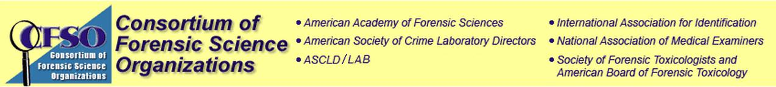
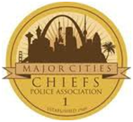
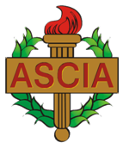
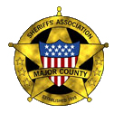
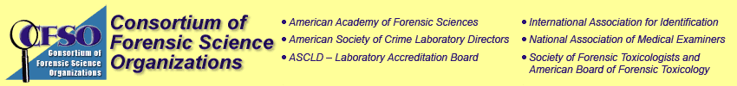
Proclamations: An official method to gain attention and show appreciation

As a way to celebrate and gain recognition for Forensic Science Week, encourage your local, regional or state government officials to issue a proclamation, which is simply a formal public statement like the example on the next page. When officials sign and promote a proclamation, the local news media has a photo or video opportunity upon which to build a story. Attention is drawn to your Forensic Science Week events and your forensic investigators and scientists are publically acknowledged, which is a primary function of the week.

Forensic Science Week also provides an opportunity for public officials and the entire community to learn more about the realities of forensic science and the vital role that it plays in our criminal justice system. This opportunity should be further expanded through activities, planned during the week, such as lab tours for policy makers, community outreach events, and staff recognition.

Proclamations are typically issued by leadership representing the federal government, states, municipalities, counties, cities or towns. To inquire about an official’s interest in issuing a proclamation, write a letter or contact a member of staff as soon as possible. There is typically a standard submission process. So, ask about the process and follow the proper steps. Many of our organizations may already have contacts with our executive and/or legislative branches of government that can provide advice and guidance on this process.

A sample proclamation has been provided on the next page; however, you or the political staffers may want to customize your proclamation for your community.

National Forensic Science Week

Whereas, forensic science is a vital public service; and
Whereas, access to quality forensic analysis dramatically improves the investigation of criminal activity, leading to the exoneration of the innocent and the prosecution of the guilty; and
Whereas, forensic science plays a critical role in public outreach and crime prevention, and is evolving in its role as an important member of the criminal justice community; and
Whereas, crime scene investigators, forensic examiners, and forensic scientists provide unbiased, accurate, and reliable analyses of evidence recovered from across the nation; and
Whereas, numerous professional organizations have recognized August 11-17, 2013, as National Forensic Science Week; and
Whereas, individuals all across the country will be celebrating this event; and
Whereas, the hard working people that compose our forensic science organizations deserve universal regard and appreciation for their commitment to proper scientific investigations for the cause of justice;
Be it known that on this (number) day of (month), I, (mayor/governor/etc’s name), (mayor/governor/etc) of (city/state/country), in recognition of this event, do hereby declare August 11-17, 2013, to be Forensic Science Week in (city/state/country), and urge residents to express their appreciation for the people, facilities and technologies that make reliable forensic science possible in our community.
Forensic Science Week Events

In order to fully recognize the contributions of forensic science in our community, we recommend considering some of the following events:

- Lab Tours for local, state and national level politicians and staffers
  - With the growing impact of forensic science on the criminal justice system, as a method of producing investigative leads, exonerating the innocent, and providing reliable evidence for prosecution, it is essential that our legislators and executives from all levels of government understand the realities of modern forensic science.
  - A template is provided on a subsequent page to invite politicians and their staff for a tour.
  - With the increase interest in national forensic committees, forensic legislation, and a growing demand for forensic services with limited resources, these tours will provide an incredible opportunity for engagement between the policy makers and the forensic practitioner.

- Recognition of staff
  - Awards ceremonies, lunch, snacks or a simple thank you throughout the week
  - The Philadelphia Police Department, for example, is planning to host a Family Day for its Office of Forensic Science. On Saturday, August 17th, the PPD will close Forensic Science Week with a picnic and limited tour of its facility for the family members of its staff. Normally, the OFS is not open to visits by family members. Therefore, this event will not only recognize the staff, but also allow them to share what they do with their family.

- Community Outreach
  - Schools, recreation centers, public libraries, local science museums, day camps are all excellent venues to host a “day with a forensic scientist.”
  - By sharing our knowledge, we will give the community a better appreciation for what we do, and just may encourage a child to have a greater interest in science and math.

ADVOCACY DIRECTIONS

- Review and edit the letter to provide specific information pertinent to your organization

- Call your Congressional Representatives and Senators’ offices and ask for the staff person who handles judiciary/forensic/law enforcement issues. ( Go to this website and enter in your zip code to find contact info for your representatives www.contactingthecongress.org/)

- Follow up with a letter to the Member of Congress. It is important that you email or fax this letter as it will not arrive to the Member for a significant period of time if it is mailed through the postal service.

- Continue to follow-up with staff. It will be important to accomplish this quickly.

- Do not limit the invitations to federal legislators. The same template and methods should be used to invite your local or state representatives for a tour of your facility.

- Areas with multiple forensic service providers may want to coordinate their efforts for tours.

(LETTERHEAD)

(Date)

The Honorable (Full Name)
(Room #) (Name) (Senate or House) Office Building
United States (Senate or House of Representatives)
Washington, DC (20510 for Senate; 20515 for House)

Re: National Forensic Science Week and the Importance of Reliable Forensic Science
Dear (Senator or Congressman/woman):

In recognition of the important role that proper forensic science plays in the investigation of crimes throughout the nation, from exonerating the innocent to identifying the guilty, several professional organizations are sponsoring a National Forensic Science Week from August 11-17, 2013 to recognize the scientific and technical professionals that serve our communities in this vital role.

As part of this week’s activities and in light of the importance of federal forensic legislation, national committees, increased demands for forensic analysis, and the significant impact that forensic science has on the criminal justice system, the INSERT ORGANIZATION, respectfully, invites you and your staff for a tour of our INSERT FACILITY NAME on INSERT DATE.
We believe that your participation in this event will provide useful information for you and your staff on the realities of modern forensic science. Additionally, your participation will assist in fully recognizing the significant contributions of our staff in providing quality forensic services to the citizens of INSERT AREA.
I look forward to working with you and your staff on any future forensic issues, and hope that you are able to join us for the celebration of National Forensic Science Week and tour of our facility.

Sincerely,

(Your Name)
(Job Title)

